SHINE Regional Partners
AgeSpan
Lawrence-Danvers
Attleboro Council on Aging Attleboro
Barnstable County Human Services Barnstable
Elder Services of Berkshire County
Pittsfield
Ethos
Boston
Friends of the Milford Senior Center
Milford
Greater Boston Chinese Golden Age Center
Boston
HESSCO
Walpole
LifePath, Inc. Greenfield
Middleborough Council on Aging Middleborough
Minuteman Senior Services Bedford
Mystic Valley Elder Services Malden
Needham Council on Aging Needham
Springfield Department of Elder Affairs Springfield

To contact a SHINE
Counselor or if you are interested in becoming a SHINE Counselor, call:
800-243-4636
MassRelay: 711 or 800-439-0183 (voice)
800-439-2370 (TTY/ASCII)
SHINE@mass.gov www.shinema.org
This project is supported in part by grant #90SAPG from the US Administration for Community Living,
Department of Health and Human Services,
Washington, D.C. Grantees undertaking projects with government sponsorship are encouraged
to express freely their findings and conclusions.
Points of view or opinions do not, therefore,
necessarily represent official ACL policy.

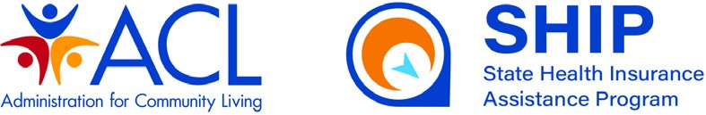

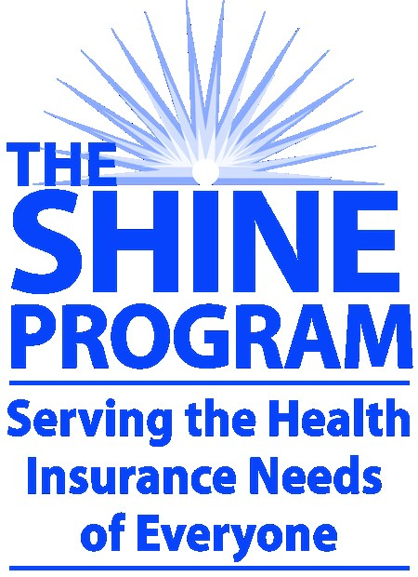

Free Health Insurance
Information, Counseling,
& Assistance for

People with Medicare

In Belmont Call (617) 993-2970 To Schedule a SHINE Appointment

What is SHINE?
Serving the Health Insurance Needs of Everyone (SHINE) provides free health insurance information, counseling, and assistance to Massachusetts residents with Medicare and their caregivers.
SHINE is administered by the
Massachusetts Executive Office of Elder Affairs in partnership with elder service agencies, Councils on Aging, and other public and private community-based organizations.
SHINE is a State Health Insurance Assistance Program (SHIP) and is partially funded by the Centers for Medicaid and Medicare Services.
What is a SHINE Counselor?
A SHINE Counselor is trained and certified by the Massachusetts Executive Office of Elder Affairs in the various options available to Medicare beneficiaries—including Medicare Parts A & B, Medicare Advantage, Medicare prescription drug coverage (Part D), Medigap, Prescription Advantage, MassHealth, and other programs that help people with limited resources pay for health care costs.
How can a SHINE Counselor help me?
SHINE Counselors help Medicare beneficiaries and their caregivers navigate the complex health insurance system.
A SHINE Counselor can explain Medicare options and how Medicare works in everyday language.
A SHINE Counselor can help you compare the costs and benefits of Medicare and other health insurance options and help you enroll in a health insurance program that best fits your needs.
A SHINE Counselor can help people with limited resources enroll in programs that help pay health insurance costs.
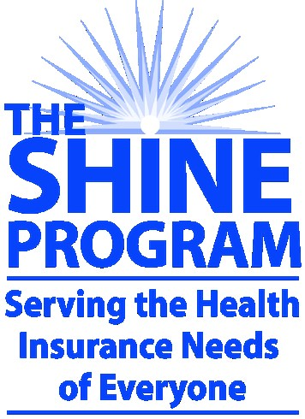
IN BELMONT CALL (617) 993-2970 TO SCHEDULE A SHINE APPOINTMENT

Common questions for SHINE Counselors
- How much does Medicare cost?
- What does Medicare pay for?
- When should I enroll?
- How do I enroll?
- How do I avoid a late enrollment penalty?
- Which parts of Medicare do I need?
- What is “Medigap” insurance?
- What is a Medicare HMO, PPO, or Medicare Advantage plan?
- Is Medicare Advantage right for me?
- Which Part D plan will cover my drugs?
- Can I get help paying my Medicare costs?
- Do I qualify for MassHealth/ Medicaid?
- Why did I receive a bill after seeing my doctor?
- How do I appeal a Medicare denial?
- Why wasn’t my drug paid for when I went to the pharmacy?
- Will Medicare pay for my nursing home stay?

