§10A - Center Gateway Overlay District (CGOD)

§ 10A.1 FRAMEWORK AND OVERVIEW
§ 10A.2 INTRODUCTION
§ 10A.3 ESTABLISHMENT OF DISTRICT
§ 10A.4 PERMITTED USES
§ 10A.5 SUPPLEMENTAL DESIGN STANDARDS

§ 10A.1 FRAMEWORK AND OVERVIEW

- APPLICABLE BY-LAWS AND REGULATIONS

This By-Law establishes the Center Gateway Overlay District (the “CGOD”), which possesses its own specialized requirements and criteria. The CGOD is also governed, as set forth in this Section 10A, by other provisions of the Zoning By-Law and the Planning Board’s Rules and Regulations.

In addition, the CGOD is intended to work in concert with Section 10, the Belmont Center Overlay District, and incorporates many of its procedural and substantive provisions by reference.

- USER’S GUIDEBOOK

The Office of Planning and Building shall promulgate a separate, non-binding, User’s Guidebook to explain how the CGOD’s Form-Based Code is used. The Guidebook shall include any and all Design Guidelines issued in the Planning Board’s Rules and Regulations. It is highly recommended that this Guidebook be reviewed as a first step in understanding this By-Law. The CGOD User’s Guidebook may be part of or separate from the User’s Guidebook required to be promulgated pursuant to Section 10.1(B).

§ 10A.2 INTRODUCTION

- PURPOSE & INTENT

The CGOD establishes Belmont’s primary entrance corridor along Concord Avenue. This district is intended to be the location for larger-scale Mixed-Use and Commercial development, including hospitality uses, and to serve as a visual anchor and signature gateway to Belmont Center.

The purpose of this district is to:

- Support landmark architecture and prominent building forms at the Town’s edge.
- Allow the greatest opportunity for vertical development and structured parking.
- Provide an appropriate transition to adjacent neighborhoods and other Overlay Zoning Districts.
- Encourage limited Mixed-Use programs that promote economic development while reinforcing Belmont’s identity.

B. APPLICABILITY

- The Center Gateway Overlay District (CGOD) is established pursuant to the authority of G.L. c. 40A, and shall be deemed to overlay the parcels depicted on the Official Zoning Map, as amended.

- The zoning rules applicable to the Base Zoning Districts shall be in effect except where the property owner elects to utilize the provisions of this Section 10A. Unless the property owner so elects, no provision of this Section 10A shall apply.

- The owner of a Lot within the CGOD must choose to use either the Base Zoning provisions or the provisions of this Section 10A for that Lot.

- Where a provision of this Section 10A states that zoning relief as to a specific dimensional, design, parking, or other narrow requirement “may” be permitted or allowed, but does not specify by whom or when, that zoning relief may be allowed by the Permitting Authority.

- Unless otherwise stated in this Section 10A, the Planning Board shall be the Special Permit Granting Authority for any Special Permits required pursuant to a provision of this Section 10A, including a Special Permit for a Formula-Based Food Service Establishment, or for any Hotel Accessory Use requiring a Special Permit. If any applicable provision of the Base Zoning requires a Special Permit, the Special Permit Granting Authority for that Special Permit shall be the Special Permit Granting Authority established in the Base Zoning.

- In the event of any conflict between the text of this Section 10A, a table, or an illustration or diagram, the text shall prevail over a table, illustration, or diagram, and a table shall prevail over an illustration or diagram.
- The Planning Board shall be charged with administering this By-Law and may promulgate rules and regulations to implement its provisions, and shall promulgate rules and regulations as specifically set forth in this Section 10A.

- No Lot may use the provisions of this Section 10A, and no Applications shall be received, reviewed, or granted, until November 1, 2026.

C. RELATIONSHIP TO BELMONT CENTER OVERLAY DISTRICT

- Incorporation by Reference: except as expressly amended, supplemented, or superseded in this Section 10A, the following provisions of Section 10 shall apply to any project in the CGOD:

  - Section 10.2 B. 4
  - Section 10.5, General Standards;
  - Section 10.6, Streets and Public Open Spaces;
  - Section 10.7, Administration; and
  - Section 10.8, Definitions.

However, except where the context clearly requires otherwise, all references to “Section 10” therein shall be read as “Section 10A.”

- Modifications: Where the provisions of the CGOD differ from an otherwise-applicable provision of the BCOD, the provisions of the CGOD shall govern.

- Shared Guidance: for consistency of architectural quality, materials, and site planning, the BCOD Guidebook applies in the CGOD to the same extent as in the BCOD.

§ 10A.3 ESTABLISHMENT OF DISTRICT

- ESTABLISHMENT OF CENTER GATEWAY OVERLAY DISTRICT (CGOD)

The Center Gateway Overlay District, shown as the Regulating Plan below, serves as the southeastern gateway to the Belmont Center area, forming a vital connection between a concentration of public facilities and Leonard Street. This district is envisioned as a vibrant, walkable destination that supports a dynamic mix of uses, reinforces a sense of place, and promotes an active public realm. This district is designed to accommodate the highest intensity and diversity of development. The scale and height of Buildings in this district are compatible with adjacent lower-scale neighborhoods due to natural and infrastructure buffers such as wide roads with a median, public spaces, and the rail line.

Figure 3-1 – Regulating Plan

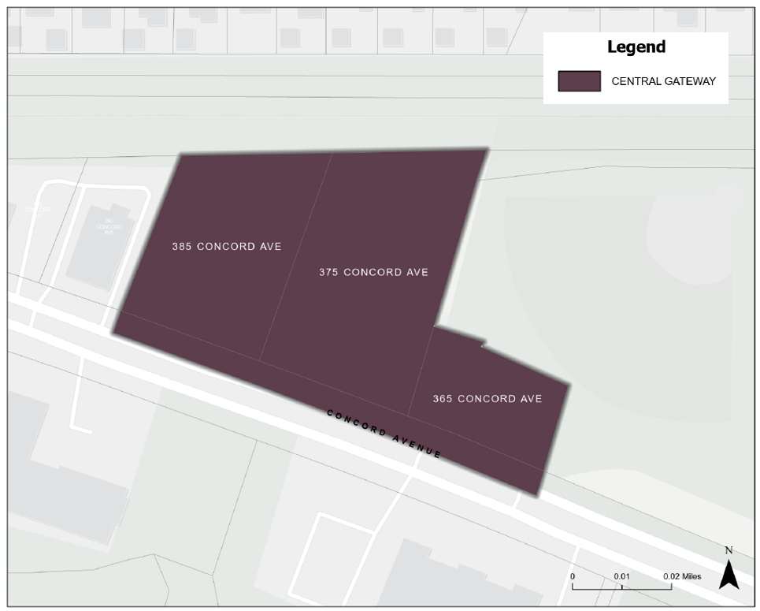

Buildings in this district are strongly encouraged to be redeveloped as a Hotel or other Commercial Uses. These uses are compatible with the overall district and support economic activity while maintaining a pedestrian-oriented streetscape. Buildings are to be situated along wide, shaded sidewalks that encourage walking and social interaction. Parking areas shall be screened from view, and shared parking is encouraged. A Parking Structure is recommended to maximize the buildable Footprint and support parking needs. The use of this Overlay District increases the Commercial square footage in the district by requiring a minimum of two floors of Commercial Use as defined in Section 10.8, Definitions.

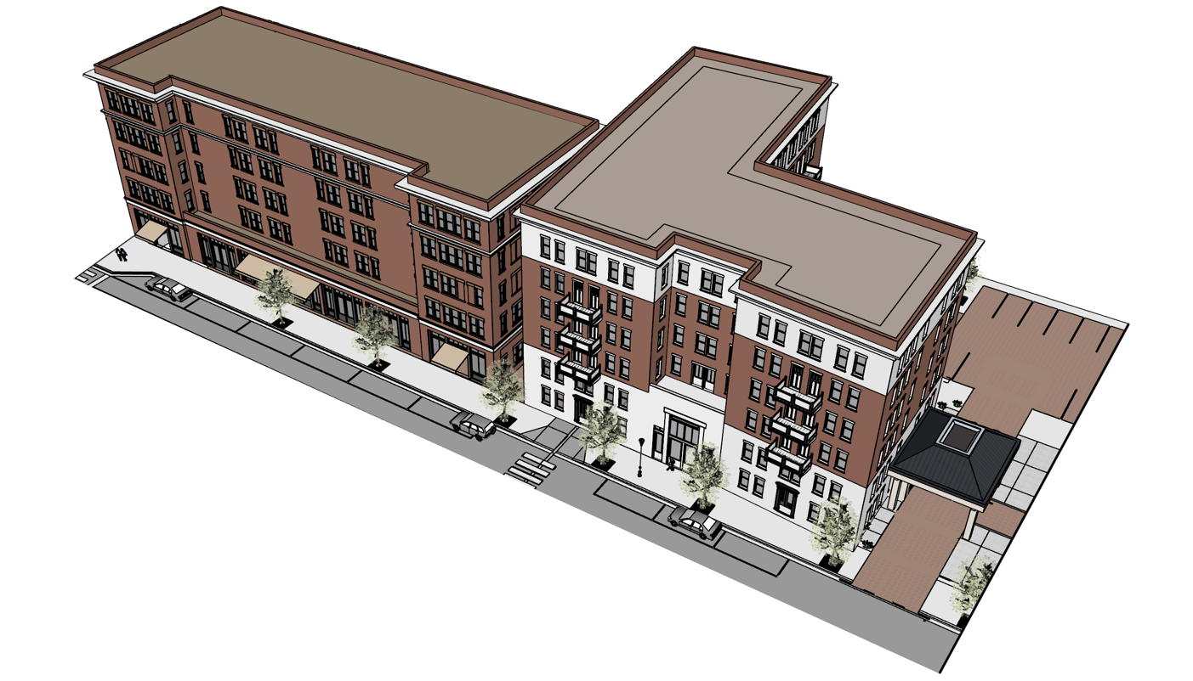

- DISTRICT SUMMARY TABLE

Table 3-1 – District Summary Table

Building Placement
Setbacks
Front Build-to-Zone or Setback | 8’ min. to 20’ max.
Side Street Build-to-Zone | 0’ min. to 10’ max.
Interior Side Property Line Setback | 0’ min.
Rear Setback | 5’ min.
Rear Setback abutting R District | 15’ min.
Side Setback abutting R district | 10’ min.
Frontage Buildout
Frontage Buildout Front Street | 80% min.
Frontage Buildout Side Street | 50% min.
Permitted Encroachments by Appurtenances

Encroachment into BTZ: Front | 8’ max.
Encroachment into BTZ: Side Street | 6’ max.
Encroachment into Rear Setback | 3’ max.
Residual Setback from Property Line: Front | 3’
Residual Setback from Property Line: Side Street | 3’
Residual Setback from Property Line: Rear | 2’
Coverage
Impervious Coverage (% maximum) | 95%
Open Space (% minimum) | 5%
Building Form
Building Height
Main Building Height | 5 stories
Main Building Height | 55.5’
Ground Floor Height | 13’ to 15’  . floor-to-floor
Upper Floor(s) Story Height | 8’ min. clear  9.5’ floor-to-floor
Half-Story Height | 12’ max. (flat roof)
Frontage Type
Depth, Ground Floor Active Use | 20’ min.
Ground Floor Fenestration | 60% min.
Allowed Frontage Types | Storefront covering 50% of the combined width of the primary and secondary facades, Gallery
Parking Location (Distance from Property Line)
Front Setback | 20’ min.
Side Street Setback | 3’ min.
Side Setback | 0’ min.
Rear Setback | 5’ min.

- OVERLAY DISTRICT REQUIREMENTS

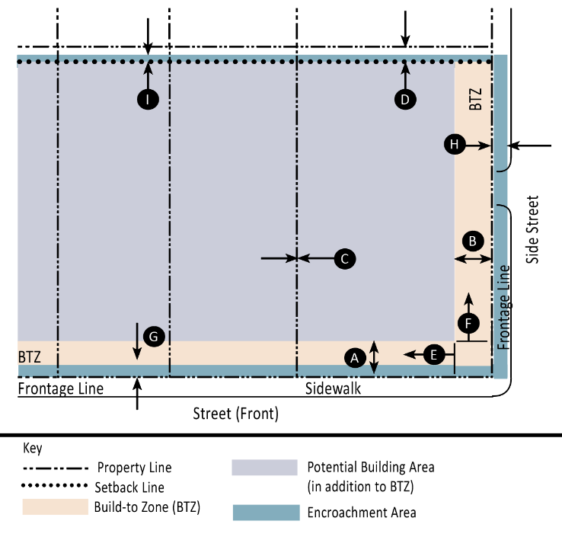 | 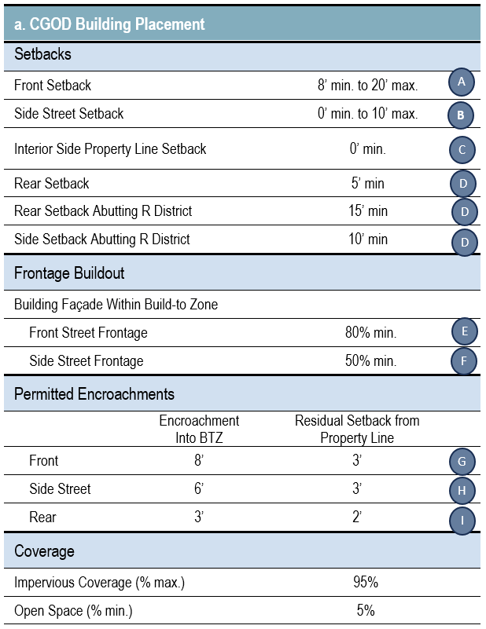
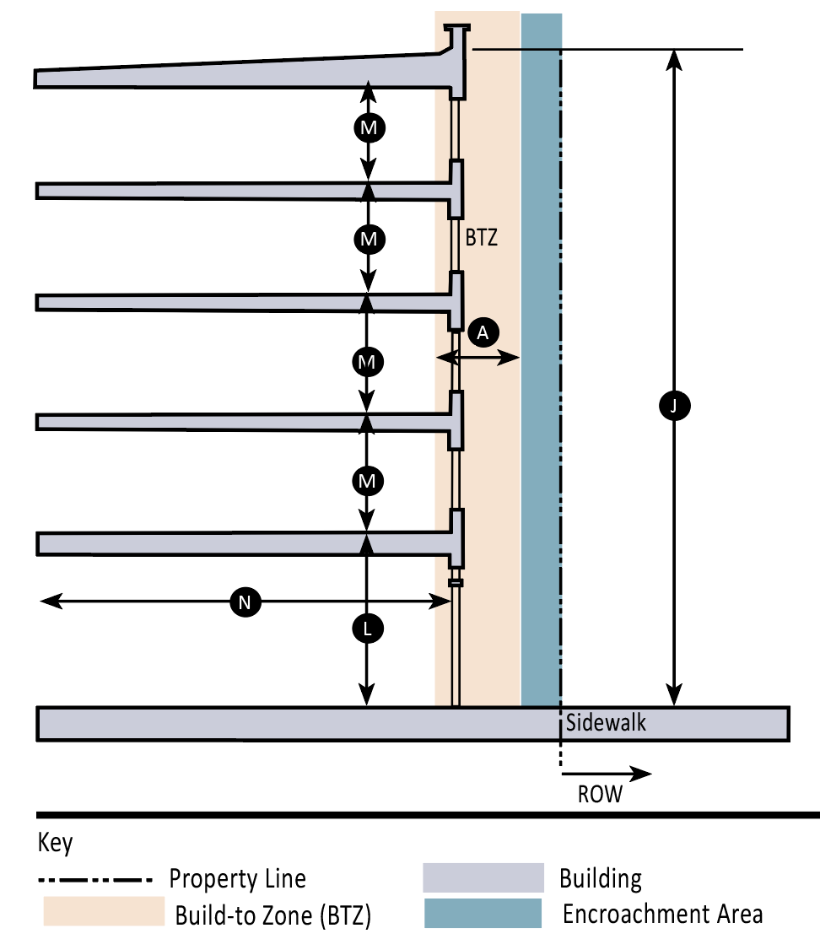 | 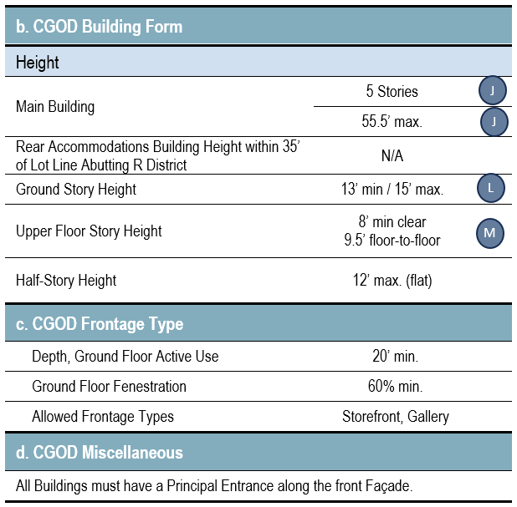

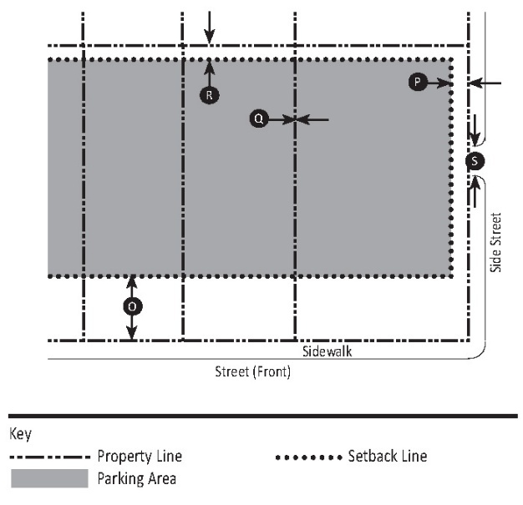 | 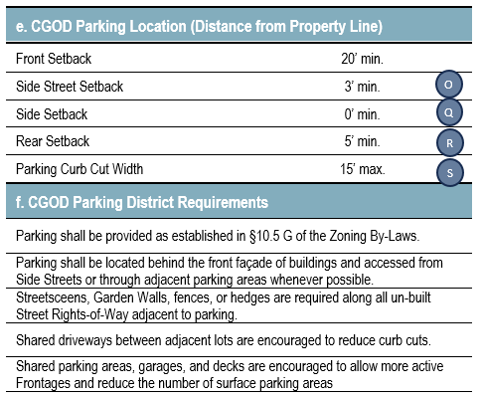
§ 10A.4 PERMITTED USES

The Use and Parking Requirements Table below lists the various types of uses and identifies whether or not a Use is permitted By Right, By Special Permit, or as an Accessory Use using the codes below.

Allowed By-Right | Y (Yes)
Not Allowed | N (No)
Allowed By-Right as Accessory Only | A
Allowed By Special Permit as Accessory | A-SP

- USE NOT LISTED

Uses that are not listed are not allowed.

- USE TABLE AND ASSOCIATED PARKING REQUIREMENTS

Table 3-2

USE AND PARKING REQUIREMENTS TABLE
RESIDENTIAL USES |  | Parking Requirements
Senior Active-Living Residential | SP | 0.3 / Unit
COMMERCIAL USE |  | Parking Requirements
Bank (Financial Services) | A | 1 per 600 s.f. GFA
Bar or Tavern | A | 1 per 5 Seats
Business Incubator & Shared Workspaces | N | 1 per 600 s.f. GFA
Business Services | Y | 1 per 600 s.f. GFA
Car Sharing or Rental | A | N/A
Bicycle or Scooter Rental | A | N/A
Broadcast Media Studio | N | N/A
Car Charging Station | A | N/A
Craft Beverage Establishment | A | 1 per 5 Seats
Food Service Establishment | Y | 1 per 5 Seats
Food Service Establishment, Formula Based | A-SP | 1 per 5 Seats
Hotel, Class 2 or 3 | Y | 0.5 per Guest Room + 0.25 spaces per employee²
Hotel Guest Serving Accessory Use | Refer to Section 6.15, Hotels
Hotel Public Facing Accessory Use | Refer to Section 6.15, Hotels
Job Printing, Retail Scale | N | N/A
Health and Wellness Services | Y | 1 per 600 s.f. GFA
Mixed-Use with Senior Active-Living Residential as Residential Component | SP | Based on Each Use
Office, General | Y | 1 per 600 s.f. GFA
Open Air Business | A-SP | 1 per 350 s.f. GFA
Parking Structure or Surface Parking Lot, Commercial | A | N/A
Personal Services | A | 1 per 600 s.f. GFA
Place of Assembly, Amusement, or Exercise | Y | 1 per 600 s.f. GFA
Retail | Y | 1 per 350 s.f. GFA
Rooftop dining, bar, or event space | A | 1 per 5 Seats
CIVIC / INSTITUTIONAL USE |  | Parking Requirements
Arts Exhibition Area | A | 1 per 550 s.f. GFA
Day Care Center | Y | 1 per 600 s.f. GFA
Art Gallery or Museum | A | 1 per 550 s.f. GFA
Religious & Educational Uses  Protected by M.G.L. 40A. § 3 | Y | 1 per 550 s.f. GFA
School, Private, for Profit | SP | 1 per 550 s.f. GFA
Arts Education | A | 1 per 600 s.f. GFA
Theatre or Performance Space | A | 1 per 3 fixed seats plus 1 per 36 s.f. of unseated GFA
OTHER USES |  | Parking Requirements
Brewery, Cidery, Winery, Meadery, Distillery (non-micro) | SP | 1 per 5 Seats
Artisan Manufacturing or Assembly | SP | 1 per 600 s.f. GFA
Research & Development or Laboratory | Y | 1 per 1000 s.f. GFA
§ 10A.5 SUPPLEMENTAL DESIGN STANDARDS

- BUILDING TYPES

- Purpose

This Section sets forth the standards applicable to the development of each Building type within the CGOD. These standards supplement the Building Standards provided in Section 10.5 D. These standards are intended to ensure development that aligns with the purpose and intent of this Section.

- Building Types Overview

  - Table 3-3 describes the Building types permitted in the CGOD.
Table 3-3 – Building Types General
Building Type & Description
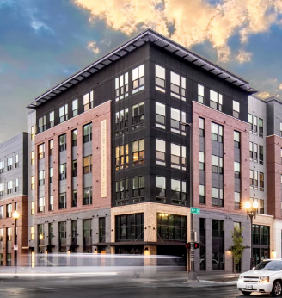 | Mid-Rise. This Building type is a medium-to large-sized structure, 5–6 stories tall, built on a large Lot that typically incorporates structured parking. It can be used to provide a vertical mix of uses with ground-floor Retail, or service uses and upper-floor service, or residential uses; or may be a single-use Commercial buildings.
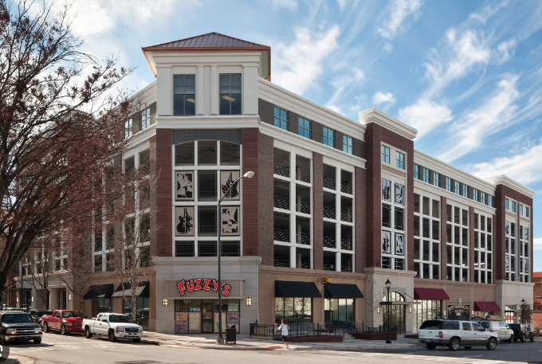 | Liner Building. A Liner Building is a structure, often narrow and/or shallow, built to conceal or shield less appealing or functional elements of a Building or site, such as parking areas, service areas, or utility structures, while providing a more aesthetically pleasing Street Frontage. Essentially, it masks or conceals what is behind it.
- FRONTAGE TYPES

A Storefront Frontage is required for a minimum of 50% of the combined width of the frontage of any Building in the CGOD. No Frontage type is required for the remainder of the frontage, but the Fenestration and other Building composition requirements of Section 10.5 shall still apply.

- PARKING

The provisions of Section 10.5.G shall apply to any project within the CGOD except that parking shall be provided for each Use in accordance with Section 10A.4, Table 3-2, Parking Requirements, instead of Section 10.4, Table 4-1.

- REVIEW AND APPROVAL

      - All development within the CGOD shall require Design and Site Plan Review, a Special Permit, or both as set out in this Section 10A and Section 7.

      - Applications for Design and Site Plan Review or Special Permits for a Hotel within the CGOD shall be subject to the procedural requirements of Section 6.15.8 in addition to any other procedures required by this Section 10A

SECTION 6. SPECIAL REGULATIONS

  - Hotel Use Regulations

    - Generally

The Town of Belmont permits three classes of Hotels within designated zoning districts.

    - Purpose

The purpose of this Section 6.15 is to regulate the location and design of Hotels in Belmont in order to promote economic development, provide high-quality lodging facilities, protect adjacent residential neighborhoods, ensure adequate transportation and parking, and maintain high-quality design standards.

    - Applicability

- This Section 6.15 shall apply to all eligible parcels located within the boundaries of the districts designated in Section 6.15.4 below as shown on the Zoning Map.

- The requirements of this Section 6.15 supplement the requirements of the underlying zoning district or overlay district in which the proposed Hotel is to be located. If there is a conflict between those requirements and those in this Section 6.15, the requirements of this Section 6.15 shall control.

    - Establishment

Hotels of the following class(es) are permitted by-right in the following zoning district(s):

- Center Gateway Overlay District – Classes 2 and 3, provided that no applications for Design and Site Plan Review or a Special Permit for a Hotel shall be received, reviewed, or granted, until November 1, 2026.

    - Definitions

In this Section 6.15, terms defined in Section 1.4 of this By-Law shall have the definitions provided there (regardless of capitalization), and the following terms shall have the meanings given below:

- Accessory Use, Guest Serving – Accessory use within the facility or on the grounds of the Hotel that are intended for use by the guests, Hotel staff, or both, or their guests, but not the general public.

- Accessory Use, Public Facing – Accessory use associated with the facility and intended for use by the general public, such as a street-level retail or food service establishment.

- Facility Gross Floor Area (GFA) – The sum of the Gross Floor Area of the principal building(s) and any accessory buildings serving a Use in a principal building, including any outdoor patios or dining, bar, or event areas at 50% of the square footage of the space (e.g., 2,000 sf patio counts as 1,000 sf toward the cap), but excluding structured parking.

- Guest Room – A single rentable lodging unit within a Hotel designed and used for transient overnight occupancy under a single rental agreement, with at least one bathroom included within the unit, regardless of the number of internal rooms or spaces contained within the unit. References in this Section 6.15 to the number of rooms in a Hotel shall mean the number of Guest Rooms, and not the number of rooms or spaces located within any individual Guest Room.

- Guest Room Area – The total Gross Floor Area of all Guest Rooms (excluding Guest Room balconies) and corridors, alcoves, and linen or housekeeping closets on guest floors.

- Hotel – A Building, or portion of a Building with access provided through a common entrance, lobby, or hallway to one or more Guest Rooms, designed to be rented out as overnight accommodations for guests. Valet parking, bellhop services, room service operations, concierge services, event coordination services, business centers, technology support, housekeeping and laundry facilities, maintenance facilities, mechanical rooms, electrical facilities, staff facilities and offices, internal lobbies or foyers not customarily open to the general public, trash and recycling enclosures, and other Uses customary, incidental, and subordinate in area and function to Hotel operations shall all be considered part of the Hotel use rather than accessory Uses. This definition shall not include a Bed and Breakfast Home, Lodging House, or Motel, as those terms are defined in G.L. c. 140 or c. 64G.

- Hotel, Class 1 (“Inn”) – A small Hotel with 25 or fewer Guest Rooms that does not offer outdoor activities.

- Hotel, Class 2 (“Boutique”) – A small-to-moderate-sized Hotel with between 26 and 100 Guest Rooms with amenities for guests or the public such as concierge services, fitness or spa facilities, or cafe.

- Hotel, Class 3 (“Business Class”) – A larger Hotel with 101-150 Guest Rooms designed primarily to serve business travelers and short-term guests, including Guest Rooms equipped with work areas and communications technology suitable for business use, and providing amenities such as meeting or conference rooms, business centers, and a fitness or wellness center for the convenience of guests.

- Major Intersection –The junction of two or more Streets that are functionally classified as major arterial or collector roadways.

    - General Requirements

- The applicant shall demonstrate, to the satisfaction of the Planning Board during the Design and Site Plan Review process, measures such as management by a professional management company with appropriate experience in Hotel operations to ensure compliance with approved plans and any conditions imposed, and a reasonable probability of receiving any and all other required licenses.

- Each Guest Room must have its own bathroom.

    - Design Quality and Amenity Standards

Hotels must meet design and amenity standards appropriate for Belmont’s status as a gateway to Boston, including:
- Exterior architecture utilizing materials and design elements consistent with documented historic, civic, architecturally significant, or other signature properties in Belmont, and any requirements of the zoning district or overlay district in which the Hotel is located;

- Any Class 2 or 3 Hotel must provide at least one of each of the following three types of amenities:

  - a social lounge or patio open to the public;
  - a Food Service Establishment; and
  - a fitness center, gymnasium, spa, or other dedicated fitness or wellness facility for guest use, which may be scaled appropriately to the size and character of the Hotel; and

- Site and building layouts demonstrate safe, accessible, and attractive pedestrian pathways, with features such as landscaping, seating, and lighting per this Section 6.15 and any requirements of the zoning district or overlay district in which the Hotel is located.

    - Site and Building Development Requirements

- The primary driveway for a Class 2 or 3 Hotel shall be within 1,000 feet of a Major Intersection.

- Parking requirements for Hotels shall comply with the requirements of the zoning district or overlay district in which they are proposed to be located.

- Regardless of any loading requirements for the zoning district or overlay district in which the Hotel is located, loading requirements for Hotels shall be as follows:

  - Class 1 and 2: No loading area permitted. Loading and unloading may occur during the hours of 7:00 am to 7:00 pm, Monday through Friday only, and may not obstruct the public Right-Of-Way.

  - Class 3: May have a loading area of up to 2,000 square feet, located to the side or rear of the facility, and screened from any residential use. Loading and unloading may occur during the hours of 7:00 am to 7:00 pm, Monday through Saturday only.

- Any signs shall comply with Section 5.2 of the Zoning By-Laws.

- In addition to any requirements imposed by Section 5.4 of the Zoning By-Laws for solid waste receptacles, any such receptacles for Hotels must be discreetly located in side or rear yards only and screened with a stockade or other decorative fencing that completely obscures the trash receptacle from view. Waste removal services shall occur from 8:00 AM – 5:00 PM only.

- Landscaping for Hotels shall comply with Section 5.3 of the Zoning By-Laws.

- Unless the zoning district in which the Hotel is located has its own lighting requirements or regulations, lighting for Hotels shall comply with Section 5.4.3 of the Zoning By-Laws.

- To ensure the Hotel use remains predominant and to keep external impacts proportionate, the Planning Board shall determine whether the proposed design and layout appropriately balances guestroom area and common/accessory areas, the following standards apply:

- In any Hotel, Guest Room Area shall make up at least the following proportion of Facility GFA:

  - Class 1 (Inns): 50%
  - Class 2 (Boutique Hotels): 47.5%
  - Class 3 (Business Class Hotels): 45%

- In any Hotel, Public- and Guest-Facing Accessory Uses shall make up no more than the following proportion of Facility GFA:

  - Class 1: 15%
  - Class 2: 20%
  - Class 3: 25%

- Submittal and Review.
With any application for Design and Site Plan Review or a Special Permit, applicants shall provide a “Program Area Table” that:

- Shows how much each floor contributes to Facility GFA;
- Lists each accessory Use and how much GFA is associated with each Use on each floor;
- Calculates Guest Room Area, GFA associated with Public- and Guest-Facing Accessory Uses, and Facility GFA, and shows the resulting percentages vs. the thresholds in (a) and (b).
- Identifies the number of Guest Rooms in each of three size classes: 300-450 s.f., 451-650 square feet and 650 or larger square feet The size of Guest Rooms shall be measured by square feet of usable space, including bathroom and storage space, but excluding balcony space.

The Planning Board may condition approval on the project remaining consistent with the figures and ratios shown in the Program Area Table, and require that any material change be made only after an amendment to the Design and Site Plan Review or the Special Permit, as applicable.

- Limited Modifications.
The Planning Board may allow a modification of the percentages in a) or b) by up to 10 percentage points by Design and Site Plan Review, or by more than 10 percentage points by Special Permit, upon written findings that:

- The Hotel Use remains the predominant Use;
- Transportation and neighborhood impacts are appropriately mitigated (by, e.g., a transportation demand management plan, shared parking, or a loading plan); and
- The project results in superior urban-design and public-realm outcomes consistent with applicable provisions in the governing provisions of the Zoning By-Law and any applicable Design Guidelines contained in the Planning Board’s Rules and Regulations.

- Relation to Accessory-Use Permissions (Table 1).
This subsection governs only the percentage limits on Guest Room Area and Public- and Guest-Facing Accessory Uses within Facility Gross Floor Area. It does not alter whether a specific accessory Use is permitted, prohibited, or requires a Special Permit, which remains controlled by Table 1 below.

    - Permitted Uses by Class

Table 1 – Permitted Accessory and Ancillary Uses for Hotels by Class

Facility Type | Class 1 | Class 2 | Class 3
Guest Serving Accessory Uses
Beauty or Barber Shop | N | Y | Y
Business Office, Guest Use | Y | Y | Y
Coffee Shop or Café | SPP | Y | Y
Conference and Meeting Facilities | N | SPP | Y
Facility Management Offices | Y | Y | Y
Facility Storage, Staff Use Only | Y | Y | Y
Fitness or Wellness Facility, Guest Use | SPP | Y | Y
Gift Shop, Guest Use | Y | Y | Y
Landscaping Facilities | N | SPP | Y
Laundry Facilities, Staff Use Only | N | Y | Y
Loading Dock | N | N | Y
Maintenance Facilities | Y | Y | Y
Outdoor Patio, Guest Use | SPP | Y | Y
Outdoor Pool or Recreation Area | N | SPP | Y
Parlor or Community Room, Guest Use | Y | Y | Y
Restaurant or Tavern, Guest Use | SPP | Y | Y
Vending Area, Interior Only | Y | Y | Y
Public Facing Accessory Uses
General Retail Use (not to exceed 2,000 s.f.) | N | Y | N
Restaurant or Tavern | N | Y | Y
Social Lounge or Outdoor Patio, Public Use | N | Y | Y

Key: Y = Yes; N = No; SPP = Special Permit from Planning Board

    - Application and Review Procedures

- The Planning Board shall be the Special Permit Granting Authority for any Hotel Use or Guest Serving or Public Facing Accessory Use requiring a Special Permit. All Special Permit applications shall be governed by Section 7.4 of this Zoning By-Law.

- All Hotels that do not require the issuance of a Special Permit shall be permitted by-right subject to Design and Site Plan Review in accordance with Section 7.3 of this Zoning By-Law.

- During Design and Site Plan Review or while considering whether to grant a Special Permit, in addition to any other factors set out in Section 7 of this Zoning By-Law, the Planning Board shall consider the following factors:

  - Whether the proposed Hotel provides facilities and amenities consistent with a Hotel of its size and class, such as on-site dining, guest common areas, meeting or event space, or fitness or wellness facilities, as applicable.

  - For a proposed Class 2 or 3 Hotel that would be located on a block zoned in significant part for ground-floor Commercial Uses, whether the Hotel includes ground floor retail or service Uses adjacent to the street.

  - Whether to impose transportation demand measures, proportionate to project scale and impacts, such as contracted shuttle or paratransit services, shared mobility programs, or contributions to off-site mobility improvements.

Only as a component to a Mixed-Use Building with at least two floors of Commercial uses.
² Guest and employee spaces may be shared if peak demand periods do not overlap.

