§ 10 Belmont Center Overlay District (“BCOD”)

§ 10.1 Framework and Overview
§ 10.2 Introduction
§ 10.3 Form-Based Overlay Districts
§ 10.4 Permitted Uses
§ 10.5 General Standards
§ 10.6 Streets and Public Spaces
§ 10.7 Administration
§ 10.8 Definitions

§ 10.1 FRAMEWORK AND OVERVIEW

APPLICABLE BY-LAWS AND REGULATIONS

This By-Law establishes the Belmont Center Overlay District (the “BCOD”), which possesses its own specialized requirements and criteria. The BCOD is also governed, as set forth below, by other provisions of the Zoning By-Law and the Planning Board’s Rules and Regulations.

USER’S GUIDEBOOK

The Office of Planning and Building shall promulgate a separate, non-binding, User’s Guidebook (the “Guidebook”) to explain how the BCOD’s Form-Based Code is used. The Guidebook shall include any and all Design Guidelines issued in the Planning Board’s Rules and Regulations. It is highly recommended that this Guidebook be reviewed as a first step in understanding this By-Law.

§ 10.2 INTRODUCTION

PURPOSE & INTENT

- To allow development and uses consistent with Belmont’s commercial centers, immediately-adjacent areas, and areas served by transit, in a manner that aligns with the vision of the Town’s long-range plans and other policy and planning documents;

- To create a strong sense of place through the utilization of good planning principles and regulatory tools;

- To encourage economic growth through the redevelopment of properties;

- To allow sufficient density and intensity of uses to promote a lively and active pedestrian environment, support and utilize available public transit, and supply a variety of land uses that serve community needs;

- To promote the health and well-being of the community by reducing automobile dependency and encouraging physical activity and the use of alternative modes of transportation;

- To encourage residential uses, to provide both a customer base for local businesses and more diverse housing types to meet local needs;

- To encourage the preservation and reuse of existing historic Buildings, as may be applicable; and

- To employ a Form-Based Code model that encourages a desirable town form, provides a more predictable set of development outcomes, and ensures consistency with long-range plans for the community.

APPLICABILITY

- The BCOD is established pursuant to the authority of G.L. c. 40A, and shall be deemed to overlay the parcels depicted on the Zoning Map, as amended.

- The zoning rules applicable to the Base Zoning Districts or another applicable overlay district shall be in effect except where the property owner elects to utilize the provisions of this Section 10. Unless the property owner so elects, no provision of this Section 10 shall apply.

- The owner of a Lot within the BCOD must choose to use the Base Zoning provisions, the provisions of this Section 10, or another applicable overlay district for that Lot.

- In addition to any provision of the Base Zoning specifically incorporated by reference elsewhere in this Section 10, the following provisions of the Base Zoning shall continue to apply to projects under this Section 10:

  - Section 1.2, Purposes.
  - Section 1.4, Definitions.
  - Section 1.5, Nonconforming Uses and Structures.
  - Section 4.3.8, Solar Energy Systems.
  - Section 5.2, Signs.
  - Section 5.4, Environmental Controls.
  - Section 6.2, Earth Removal.
  - Section 6.6, Floodplain District.
  - Section 6.8, Wireless Telecommunications Facilities.
  - Section 6.10, Inclusionary Housing.
  - Section 6.13, Special Permit Review for Formula Based Food Service Establishments.
  - Section 6.14, Accessory Dwelling Units.
  - Section 7, Administration (except as amended, supplemented, or superseded in Section 10.7).

However, in the event that the requirements or provisions of this Section 10 conflict with those of an applicable provision of the Base Zoning, either in general or with respect to a particular project, the provisions of this Section 10 shall prevail.

- Where a provision of this Section 10 states that zoning relief as to a specific dimensional, design, parking, or other narrow requirement “may” be permitted or allowed, but does not specify by whom or when, that relief may be allowed by the Permitting Authority.

- Unless otherwise stated below, the Planning Board shall be the Special Permit Granting Authority for any Special Permits required pursuant to a provision of this Section 10, including a Special Permit for a Formula-Based Food Service Establishment. If any other applicable provision of the Base Zoning requires a Special Permit, the Special Permit Granting Authority for that Special Permit shall be the Special Permit Granting Authority established in the Base Zoning.

- The invalidity, unconstitutionality, or illegality of any provision of this Section 10 or boundary shown on the Zoning Map shall not have any effect upon the validity, constitutionality, or legality of any other provision or boundary in the Zoning By-Law.
- In the event of any conflict between the text of this Section 10, a table, or an illustration or diagram, the text shall prevail over a table, illustration, or diagram, and a table shall prevail over an illustration or diagram.

- The Planning Board shall be charged with administering this Section 10. The Planning Board shall promulgate rules and regulations as specifically set forth below, and may promulgate other rules and regulations to implement the provisions of this Section 10.
- No Lot may use the provisions of this Section 10, and no Applications shall be received, reviewed, or granted, until November 1, 2026.

§ 10.3 FORM-BASED OVERLAY DISTRICTS

REGULATING PLAN

Figure 3-1 – Regulating Plan

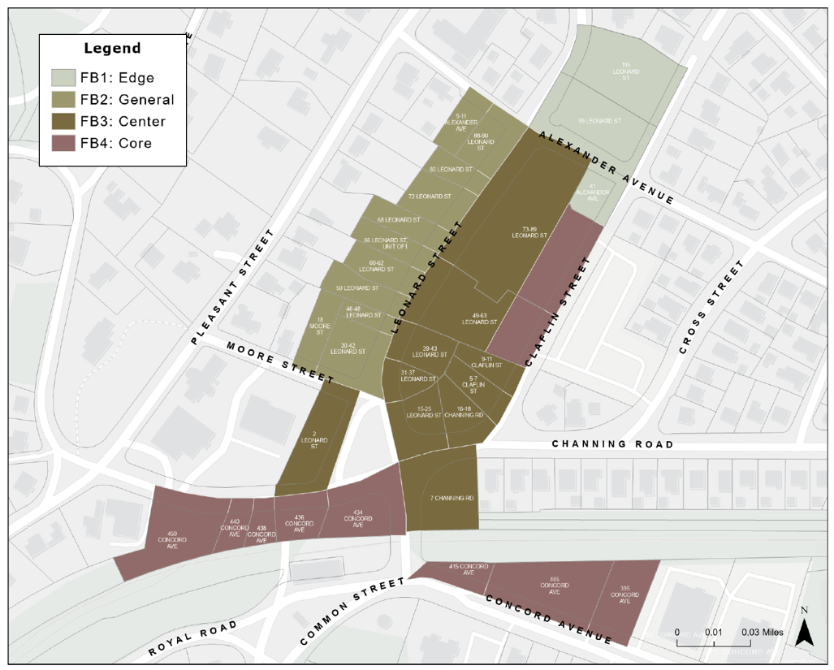

ESTABLISHMENT OF OVERLAY SUBDISTRICTS

The BCOD contains four subdistricts, as shown on Figure 3-1, Regulating Plan. Each subdistrict is defined by certain Building placements, forms, and Heights. The four subdistricts are summarized below:

Table 3-1 – Establishment of Subdistricts
FB1: EDGE | FB2: GENERAL
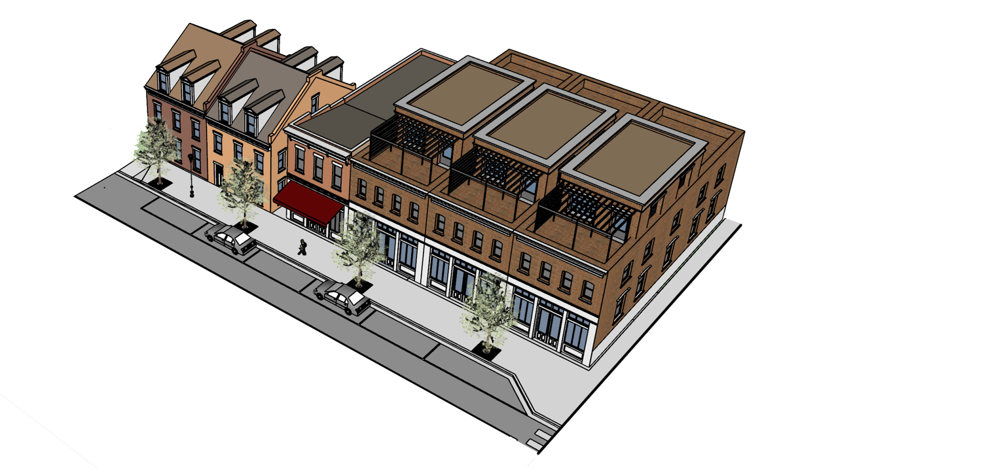 | 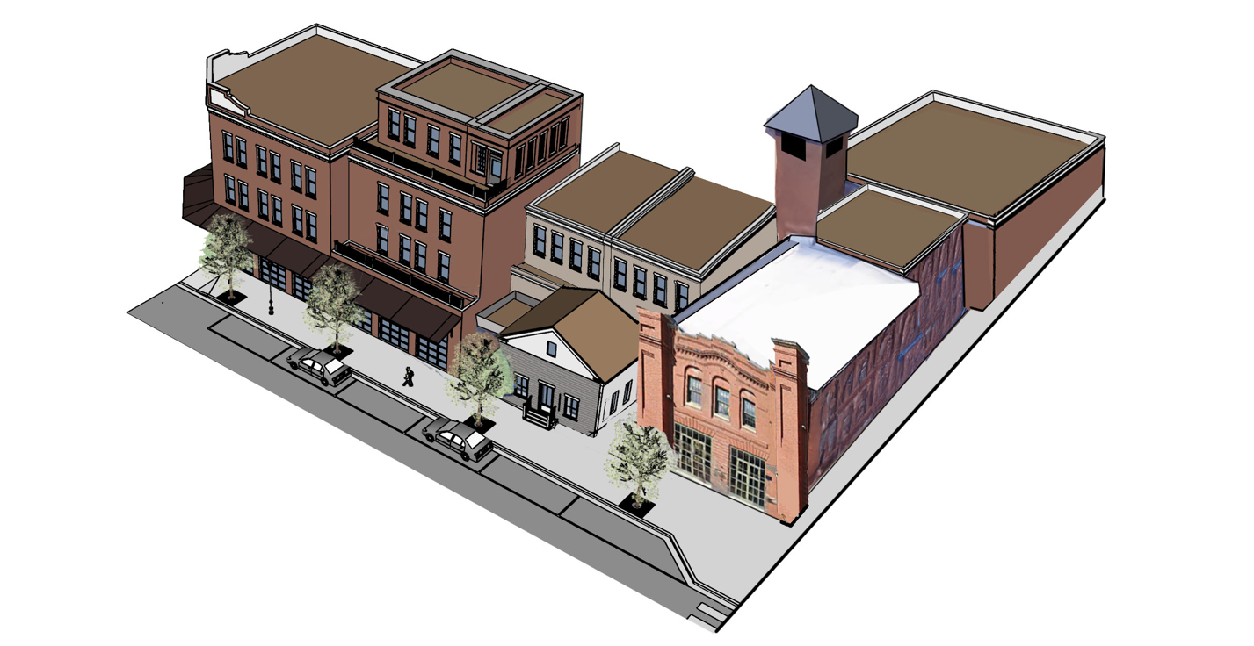
Purpose & Intent | Purpose & Intent
The FB1 subdistrict serves as a transitional zone between the denser commercial core and surrounding residential neighborhoods. It is designed to maintain the scale, rhythm, and character of nearby single- and two-family homes while subtly integrating commercial and office activity. This form supports neighborhood-serving uses such as small offices, studios, and professional services, without disrupting the residential feel. By allowing limited attached housing types and reinforcing the pitched-roof typology, this subdistrict ensures a sensitive and visually compatible edge condition that supports Walkability and a gradual increase in use intensity. | The FB2 subdistrict is a critical transition area that bridges the commercial Leonard Street corridor and the historic residential neighborhood along Pleasant Street. It enables a diverse range of small-scale commercial and Mixed-Use buildings that are compatible with nearby single-family homes. Where practicable, development should be designed to minimize impacts on the views and privacy of existing residences, particularly at the rear of the lots. This zone encourages architectural diversity and flexibility, while ensuring a harmonious relationship between different land use intensities.
Intended Form | Intended Form
- Buildings up to 2.5 stories in height  - Architectural appearance consistent with single- and two-family homes  - Commercial and office uses allowed within a residential form  - Pitched roofs strongly encouraged to maintain compatibility with adjacent neighborhoods  - Limited number of attached dwelling units or townhomes permitted | - 2.5 to 3.5 story buildings  - Mix of detached, semi-detached, and attached Building forms  - Varied front setbacks to respond to adjacent uses  - Rear yard transitions with greater setbacks, Step-Backs, and landscaping and other screening to reduce impact on neighboring residential properties  - Narrower buildings or articulation and active Frontages
Building Types | Building Types
Rowhouse/Townhouse  Main Street Small Office/Commercial | Main Street Mixed-Use
General Use | General Use
Mixed-Use, primarily commercial with allowances for townhouses. | Mixed-Use, primarily commercial with allowances for upper floor residential uses.

FB3: CENTER | FB4: CORE
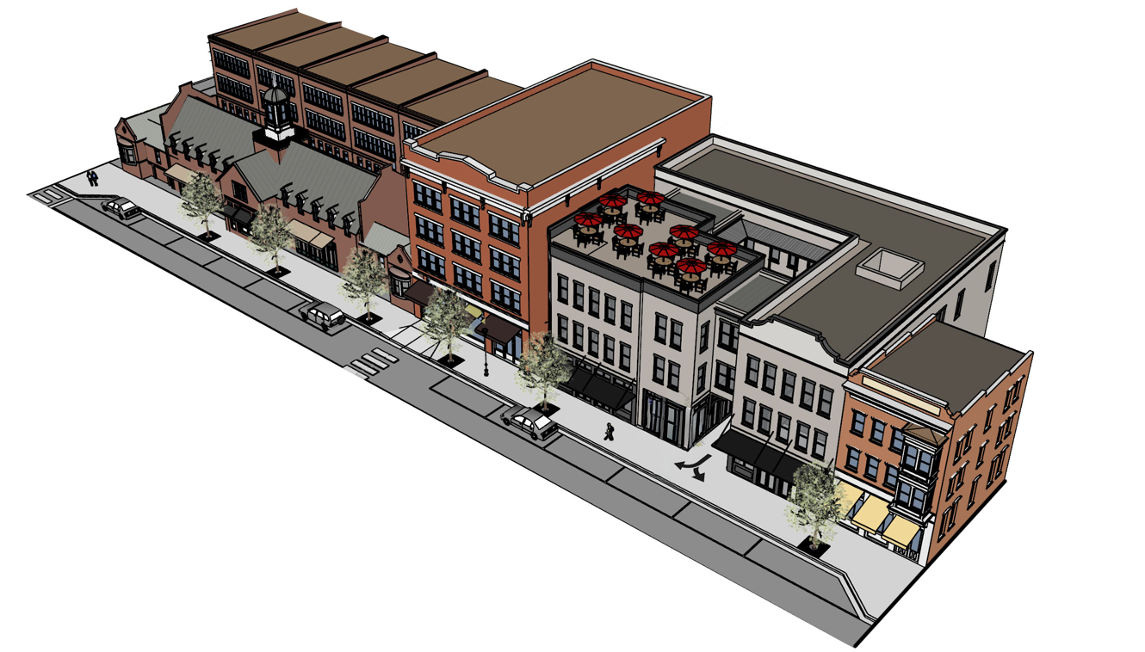 | 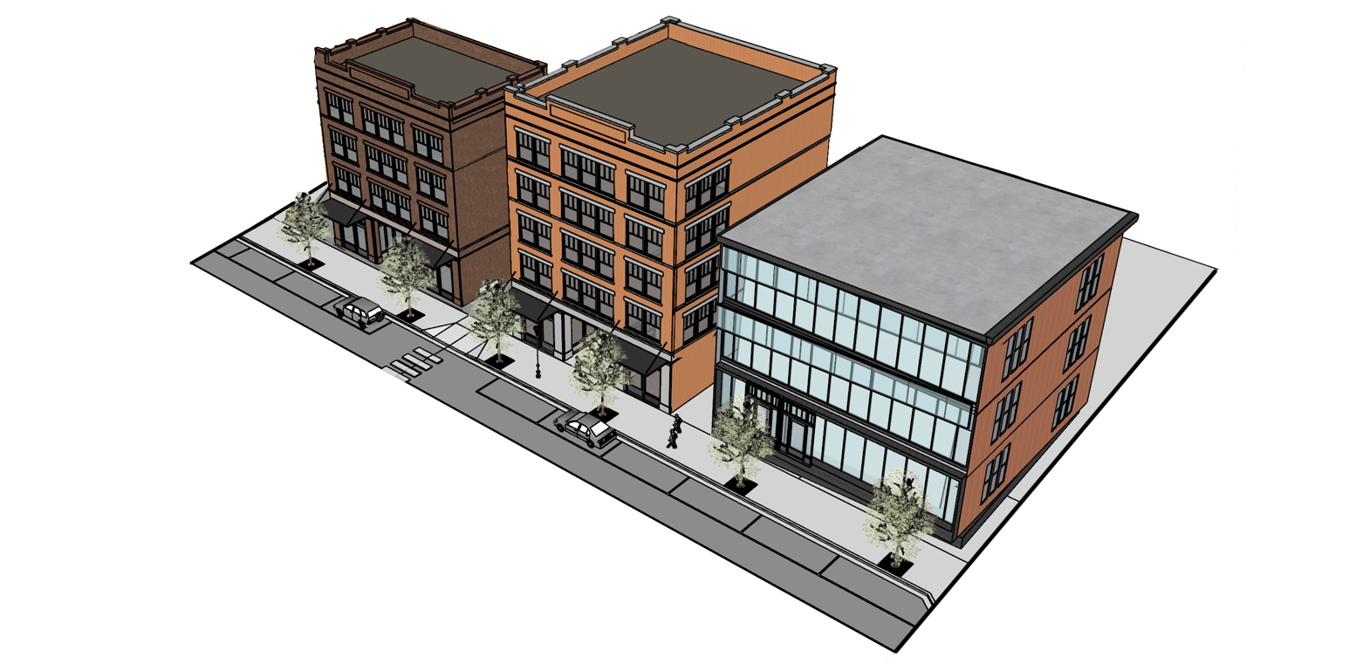
Purpose & Intent | Purpose & Intent
The FB3 subdistrict reinforces the pedestrian-oriented character of Leonard Street by preserving and enhancing its continuous streetwall and traditional Retail presence. It allows modest increases in Building Height to support new commercial opportunities, with an emphasis on human-scale design. Rooftop spaces may be used for dining, gardens, or other amenities, providing added value while respecting nearby residences. The goal is to sustain and strengthen the walkable village feel of Belmont Center, with high-quality infill and redevelopment that respects existing scale and rhythm. | The FB4 subdistrict establishes functional core of Belmont Center. Located at the heart of activity, it accommodates more intensive commercial and Mixed-Use development while supporting parking solutions that serve the broader subdistrict. The form and scale are intended to promote a vibrant, walkable environment, with buildings that define and activate the public realm along Claflin Street and Concord Avenue in line with its transit-oriented location. Structured parking integrated into Footprints or rear lots enhances accessibility and reduces the impact of surface lots. This area is key to long-term economic vitality and district-wide connectivity.
Intended Form | Intended Form
- 3 to 4 story buildings  - Attached Mixed-Use buildings with continuous streetwall  - Predominantly Flat Roofs to allow rooftop activation  - Narrower buildings or articulation and active Frontages | - 4 to 5 story buildings  - May include structured parking located behind or beneath buildings  - Flat Roofs with potential for green or activated roof uses  - Urban streetwall with minimal setbacks
Building Types | Building Types
Main Street Mixed Use | Mid-Rise  Liner Building
General Use | General Use
Mixed-Use, primarily commercial with allowances for upper floor residential uses. | Mixed-Use, primarily commercial with allowances for upper floor residential uses.

SUBDISTRICT SUMMARY TABLE
Table 3-2 – Subdistrict Summary Table
 | FB1 Edge |  | FB2 General | FB3 Center | FB4 Core
Building Placement
Setbacks
Front BTZ or Setback | 10' |  | 0’ to 10’ | 0’ to 10’ | 0’ to 10’
Side Street BTZ | 5’ min. |  | 0’ to 5’ | 5’ to 10’ | 0’ to 10’
Interior Side Property Line Setback | 0’ (attached)  7.5’ (detached) |  | 0’ (attached)  7.5’ (detached) | 0’ (attached)  7.5’ (detached) | 0’ min.
Rear Setback | 5’ min
Rear Setback abutting R District | 15’ min.
Side Setback abutting R District | 10’ min.
Frontage Buildout
Frontage Buildout Front Street | 60% min. |  | 90% min. | 90% min. | 90% min.
Frontage Buildout Side Street | 40% min. |  | 70% min. | 70% min. | 70% min.
Permitted Encroachments by Appurtenances
Encroachment into BTZ: Front | 8’ max.
Encroachment into BTZ: Side Street | 6’ max.
Encroachment into Rear Setback | 3’ max.
Residual Setback from Property Line: Front | 3’ | 0’
Residual Setback from Property Line: Side Street | 3’
Residual Setback from Property Line: Rear | 2’
Coverage
Impervious Coverage (% maximum) | 75% |  | 80% | 90% | 95%
Open Space (% minimum) | 15% |  | 10% | 10% | 5%
Building Form
Building Height
Maximum Main Building Height | 2.5 stories |  | 3.5 stories | 4 stories | 5 stories
Maximum Main Building Height | 32.5’ |  | 46’ | 46’ | 55.5’
Maximum Rear Accommodation Building Height within 35’ of Lot Line Abutting R District | N/A |  | 2.5 stories / 36’ | N/A | N/A
Ground Story Height Measured Floor-to-Floor (Refer to Section 10.5(D)(9)(f)(ii) | 11’ min. |  | 13’ to 15’ | 13’ to 15’ | 13’ to 15’
Upper Floor(s) Story Height | 8’ min. clear  9.5’ floor-to-floor |  | 8’ min. clear  9.5’ floor-to-floor | 8’ min. clear  9.5’ floor-to-floor | 8’ min. clear  9.5’ floor-to-floor
Half-Story and Top Story Height | 12’ max. Flat Roof
Half-Story Step-Back | 10’
Frontage Type
Ground Story Active Use View Depth | N/A |  | 15’ min. | 15’ min. | 15’ min.
Average Ground Story Active Use Depth | 30’ min. |  | 30’ min. | 30’ min. | 30’ min.  (15’ min. for Liner Buildings)
Minimum Ground Story Active Use Depth | 15’ |  | 15’ | 15’ | 15’
Ground Floor Fenestration | 25% min. |  | 60% min. | 70% min. | 70% min.
Allowed Frontage Types | Storefront |  | Storefront, Gallery, Forecourt | Storefront, Gallery | Storefront, Gallery
Parking Location (Minimum Distance from Property Line)
Front Parking Area Setback | 20' |  | 20’ | 20’ | 30’
Side Street Parking Area Setback | 3’ |  | 3’ | 3’ | 3’
Side Parking Area Setback | 0’ |  | 0’ | 0’ | 0'
Rear Parking Area Setback | 5’ |  | 5’ | 5’ | 5'

SPECIAL REQUIREMENTS

- PURPOSE AND INTENT

This Special Requirements Plan requires certain features to ensure that projects meet the BCOD’s goals. These features include Required Storefronts and special Rear Adjacency Accommodations. These requirements apply to both new developments and Substantial Rehabilitations of existing Buildings within these zones.

- REQUIRED STOREFRONT

In all areas designated as Required Storefront on the Special Requirements Plan Map, properties shall include Storefronts at the Street level in the location shown on the Special Requirements Plan Map.

- REAR ADJACENCY ACCOMMODATIONS

In all areas designated as needing Rear Adjacency Accommodations on the Special Requirements Plan Map, additional rear setbacks are required. These Rear Adjacency Accommodations are intended to minimize the impact of commercial lots abutting residential lots along rear and Side Lot Lines, to ensure that upper floors of commercial structures are not too close to rear and Side Lot Lines, and to ensure that private residences retain their privacy. Dimensional requirements for Rear Adjacency Accommodations can be found in Section 10.3 C. The Permitting Authority may also require other Rear Adjacency Accommodations such as landscape buffers, fencing, restrictions on window placement, screening, or other reasonable measures to ensure that the project within the BCOD is compatible in scale and character with the abutting residential district.

Figure 3-2 – Special Requirements Plan Map
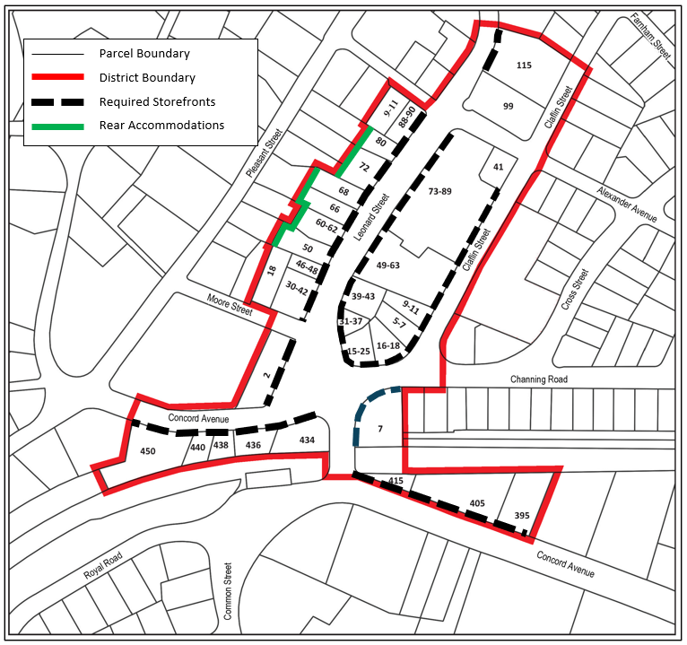

FB1 SUBDISTRICT (EDGE)

The Edge subdistrict allows residential-sized buildings on the edge of the commercial area and encourages the addition of more commercial uses as part of Mixed-Use development. In the Edge Subdistrict, buildings are required to be Street-oriented and will typically be detached. This zone is designed to maintain a residential character in the built environment, similar to the Single- and Two-Family neighborhoods that surround the Center and General Districts, while encouraging Commercial Uses.

FB1 Subdistrict Requirements

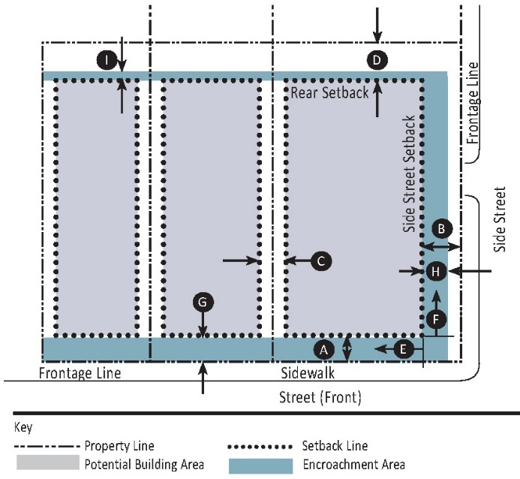 | 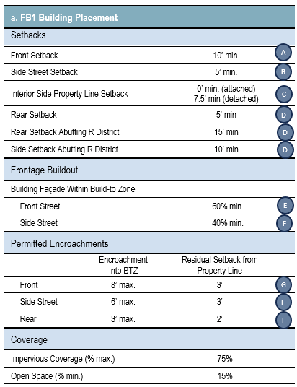

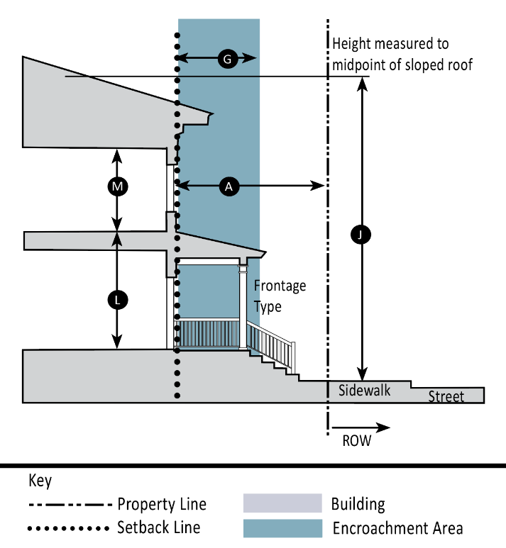 | 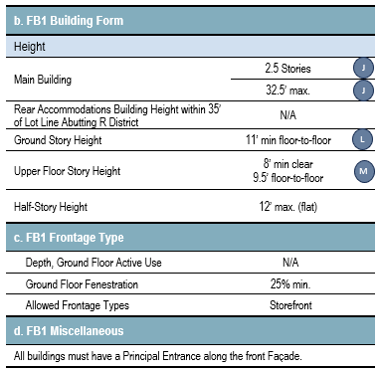

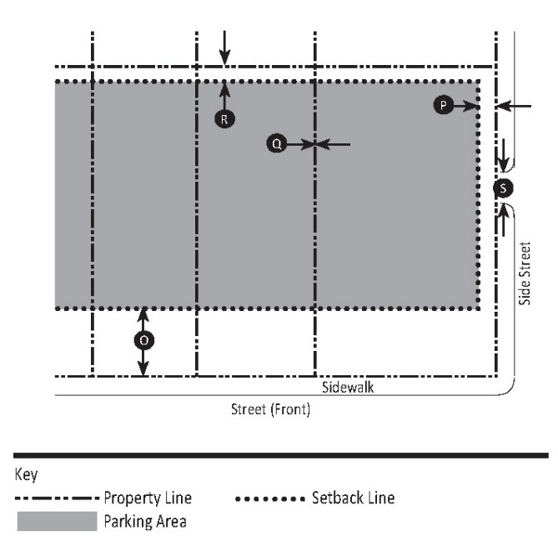 | 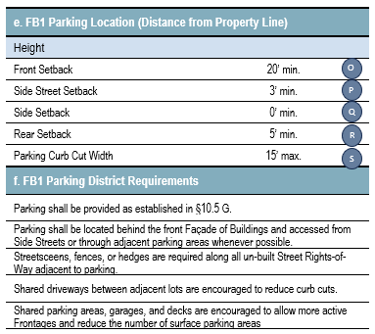

FB2 SUBDISTRICT (GENERAL)

The General subdistrict provides a transition from the main commercial areas to the surrounding residential neighborhoods. This subdistrict includes Rear Adjacency Accommodations for abutting residential uses.

FB2 Subdistrict Requirements

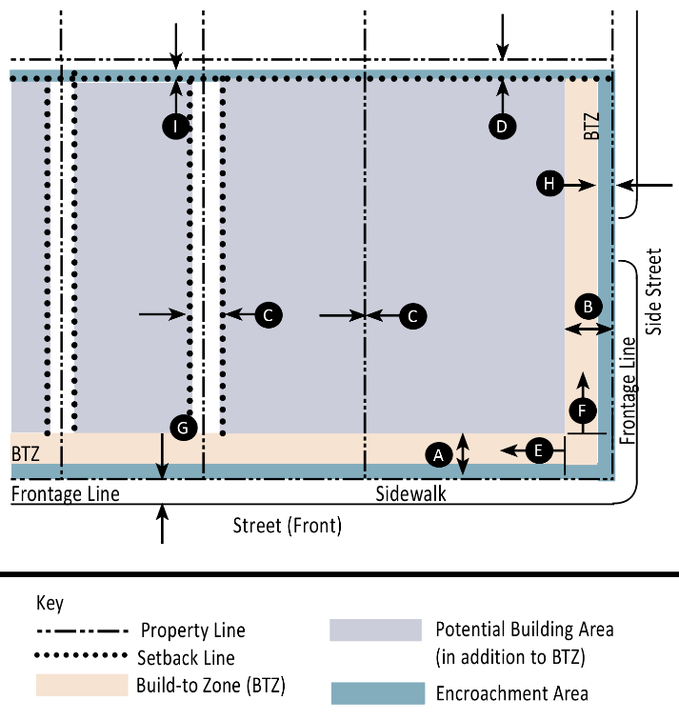 | 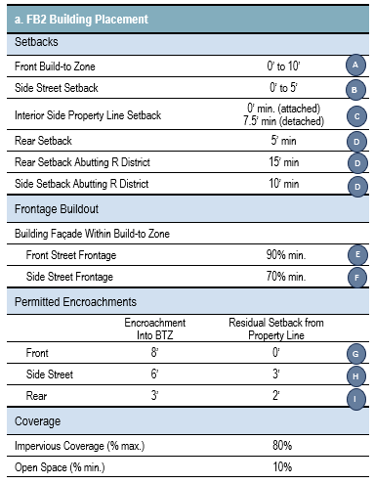

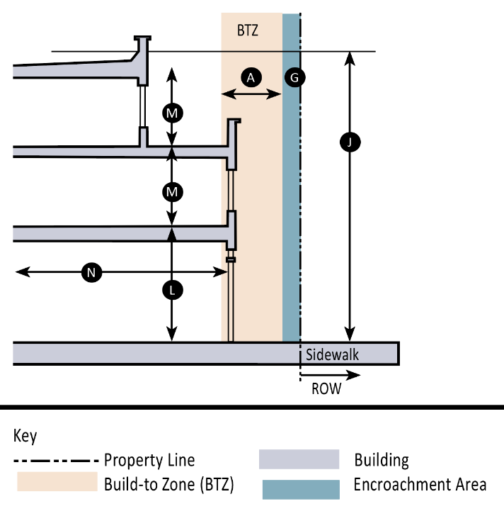 | 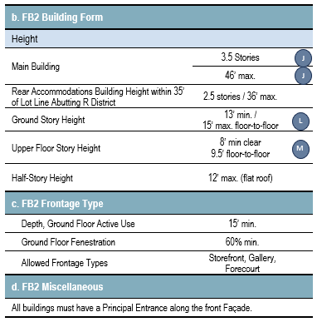

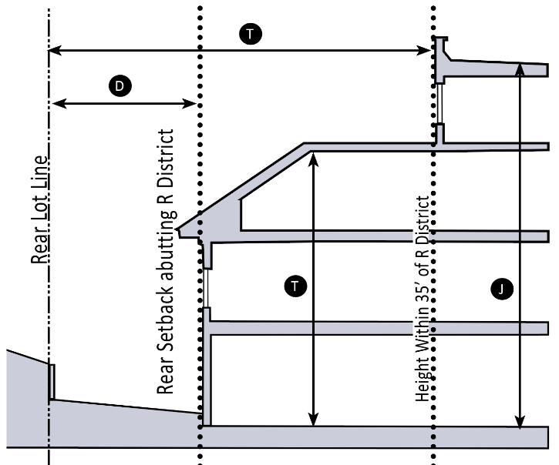 | 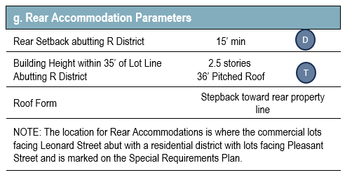

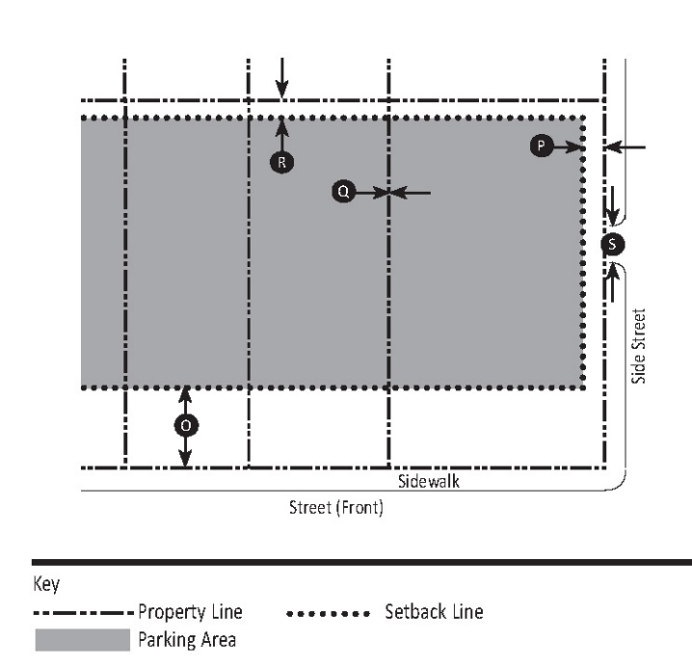 | 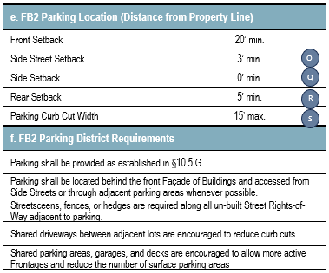

FB3 SUBDISTRICT (CENTER)

The Center subdistrict focuses on the southeast side of Leonard Street. This subdistrict is designed to keep the existing street-level character of Leonard Street while encouraging additional height and Commercial Uses for existing one-Story Buildings.

FB3 Subdistrict Requirements

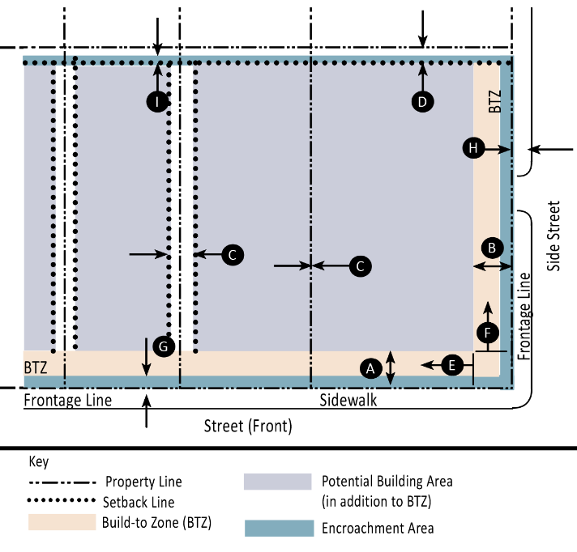 | 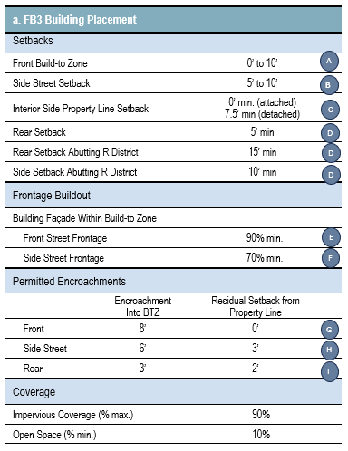

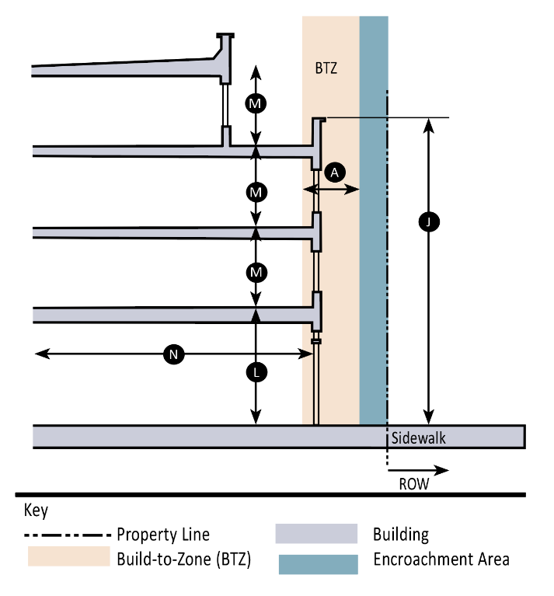 | 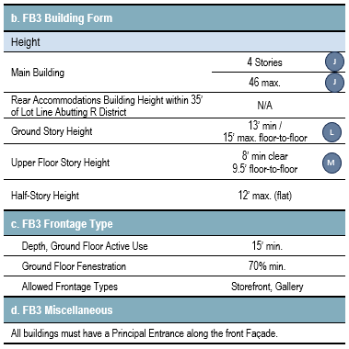

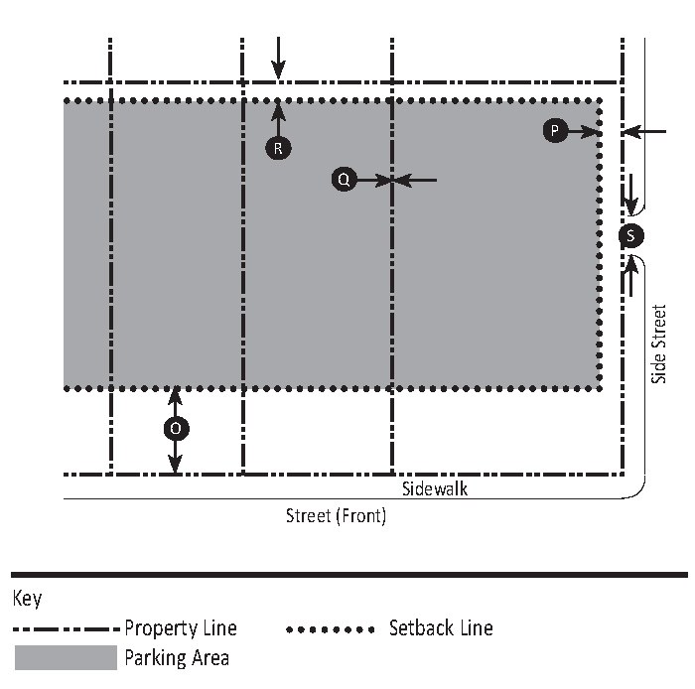 | 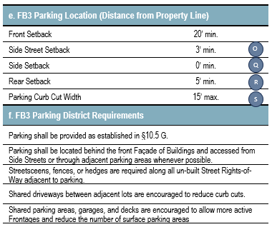

FB4 SUBDISTRICT (CORE)

The Core subdistrict is designed to form a new main Street in the Belmont Center area. Most of FB4 is located along Claflin Street, with a secondary area along Concord Avenue. To maximize vibrancy and Walkability, this subdistrict adds an additional Street for Commercial Use to the area around Claflin Street. The Core subdistrict is zoned to host a mix of commercial and residential structures, with increased Walkability as a priority. While much of the land encompassed by this subdistrict is currently a surface parking lot, the intent is for Claflin Street to transition into an active Street with Commercial Uses.

FB4 Subdistrict Requirements

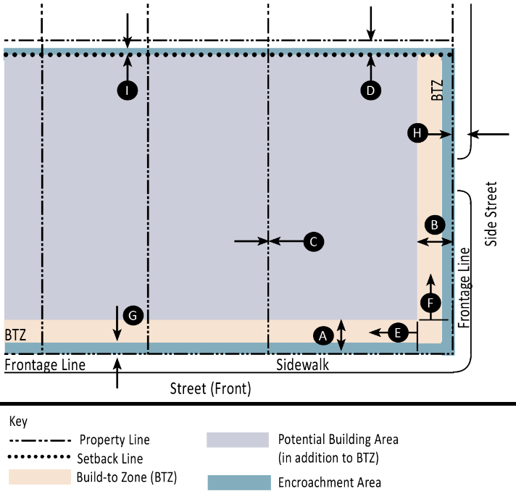 | 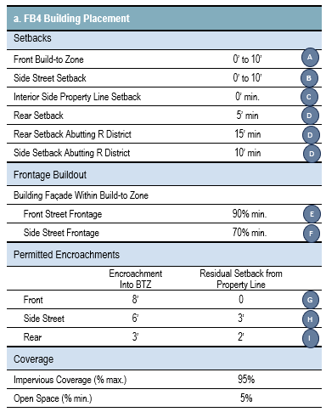

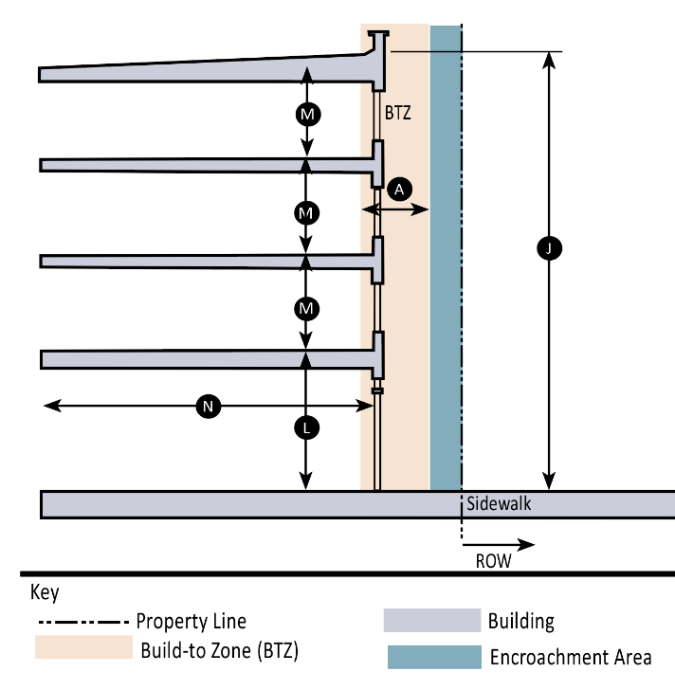 | 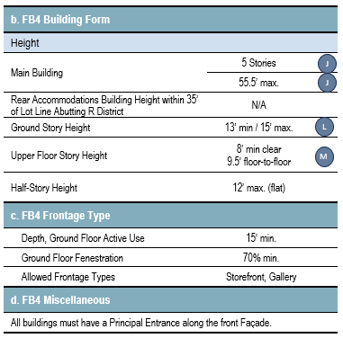

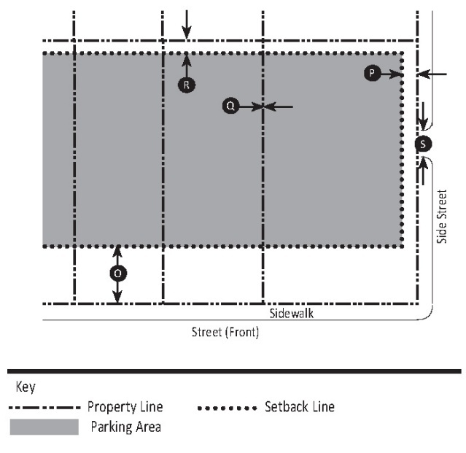 | 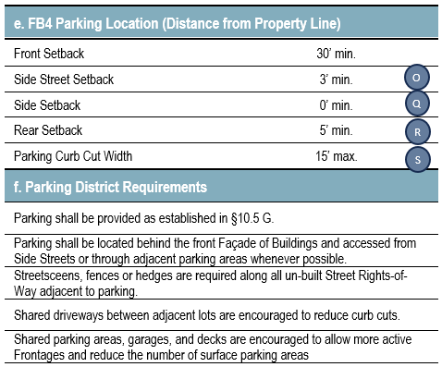

§ 10.4 PERMITTED USES

USE TABLE CODES

Use Type | Permissions
Allowed By-Right | Y (Yes)
Not Allowed | N (No)
Allowed By-Right as Accessory Only | A
Allowed By Special Permit | SP
Allowed By Special Permit as Accessory | A-SP
Allowed By-Right as Accessory Only, or as Principal Use with a Special Permit | A / SP
Temporary Use permitted by administrative permit | T

USES NOT LISTED

Uses not listed in the table below are not allowed.

USE TABLE AND ASSOCIATED PARKING REQUIREMENTS

Table 4-1

Uses | FB1 | FB2 | FB3 | FB4 | Parking Requirements  (Spaces / Unit)
RESIDENTIAL USE
Live/Work Space | SP | SP | SP | N | 0.3 / Unit
Multi-Family Residential | Y | Y | Y | Y | 0.3 / Unit
Senior Active Living Residential | Y | Y | Y | Y | 0.3 / Unit
COMMERCIAL USE
Bank (Financial Services) | Y | Y | Y | Y | 1 per 600 s.f. GFA
Bar or Tavern | A | Y | Y | Y | 1 per 5 Seats
Business Incubator & Shared Workspaces | Y | Y | Y | Y | 1 per 600 s.f. GFA
Business Services | Y | Y | Y | Y | 1 per 600 s.f. GFA
Broadcast Media Studio | N | N | Y | Y | 1 per 600 s.f. GFA
Car Charging Station | A | A | A | A | N/A
Car Sharing or Rental | N | N | N | SP | N/A
Craft Beverage Establishment | SP | Y | Y | Y | 1 per 5 Seats
Dry Cleaning/Laundry Retail (No on-site plant) | N | N | Y | Y | 1 per 600 s.f. GFA
Food Service Establishment | Y | Y | Y | Y | 1 per 5 Seats
Food Service Establishment, Formula Based | SP | SP | SP | SP | 1 per 5 Seats
Health and Wellness Services | Y | Y | Y | Y | 1 per 600 s.f. GFA
Home Occupation | A-SP | A-SP | A-SP | A-SP | 0 min. and max.
Job Printing, Retail Scale | SP | SP | SP | SP | 1 per 1,200 s.f. GFA
Mixed-Use | Y | Y | Y | Y | Sum of requirements associated with each use
Office, General | Y | Y | Y | Y | 1 per 600 s.f. GFA
Open Air Business | SP | SP | SP | SP | 1 per 350 s.f. GFA
Parking Structure | A | A | A | A | N/A
Personal Services | Y | Y | Y | Y | 1 per 600 s.f. GFA
Place of Assembly, Amusement, or Exercise | N | Y | Y | Y | 1 per 600 s.f. GFA
Pop-Up Shop | T | T | T | T | 1 per 350 s.f. GFA
Retail | Y | Y | Y | Y | 1 per 350 s.f. GFA
Rooftop dining, bar, or event space | N | A-SP | A-SP | A-SP | 1 per 5 Seats
Surface Parking Lot | A / SP | A / SP | A / SP | A / SP | N/A
PUBLIC / INSTITUTIONAL USE
Art Exhibition Area | A | A | A | A | 1 per 550 s.f. GFA
Art Gallery or Museum | Y | Y | Y | Y | 1 per 550 s.f. GFA
Arts Education (whether for-profit or not-for-profit) | Y | Y | Y | Y | 1 per 600 s.f. GFA
Community Center | Y | Y | Y | Y | 1 per 550 s.f. GFA
Day Care Center | Y | Y | Y | Y | 1 per 600 s.f. GFA
Public Use | Y | Y | Y | Y | 1 per 550 s.f. GFA
Religious & Educational Uses  Protected by G.L. c. 40A, § 3 | Y | Y | Y | Y | 1 per 550 s.f. GFA
School, Private, for Profit | SP | SP | SP | SP | 1 per 550 s.f. GFA
Theatre or Performance Space | Y | Y | Y | Y | 1 per 3 fixed seats plus 1 per 36 s.f. of unseated GFA
OTHER USES
Brewery, Cidery, Winery, Meadery, Distillery (other than a Craft Beverage Establishment) | N | N | SP | SP | 1 per 5 Seats
Research & Development or Laboratory | N | N | N | Y | 1 per 1000 s.f. GFA

MIXED-USE REQUIRED

- All developments within the BCOD must contain at least two floors of Commercial Uses, of which the ground story must be one, and contain at least one residential use.

- All Commercial, Public / Institutional, and Other Uses permitted pursuant to the use tables, whether as principal or accessory uses, and whether by-right or by Special Permit, shall be permitted only in conjunction with a residential use.

§ 10.5 GENERAL STANDARDS

PURPOSE

These General Standards apply within the BCOD and are designed to help new buildings fit the context set by the existing traditional neighborhood and commercial center characteristics. These standards also describe parking requirements; the design of signage, lighting, and Public Open Space; and other requirements.

New or Substantially-Rehabilitated Building Façades should reflect and complement the materials and general scale of Belmont’s legacy commercial structures. They should employ materials and construction techniques that will result in long-lasting structures both in durability and design expression and help deliver a high-quality public realm.

APPLICABILITY

These General Standards shall apply to all Principal and Accessory Buildings governed by this Section 10.

- The Building Standards shall apply to all new or Substantially Rehabilitated buildings governed by Section 10.
- The Site Standards (Fences and Screening; Lighting; Required Landscaping, etc.) shall apply to all Applications.

BUILDING TYPES
- Building Types Overview
  - Each lot shall only have one Building type, except as follows:

    - A lot zoned for more than one subdistrict may have up to as many Building types as the number of subdistricts the lot is zoned for.
    - An accessory Building shall have the same Building type as its associated principal Building to the extent reasonably possible, and, otherwise, shall be designed to be architecturally cohesive with the principal Building to the greatest extent possible.
    - The Permitting Authority may allow additional Building Types on a lot upon a finding by the Permitting Authority that the deviation will not detract, aesthetically or practically, from the surrounding area, the subdistrict, or the BCOD as a whole.

  - Table 5-1, Building Types General, describes Building types. A white box means the Building type is permitted in the indicated zone. A black box means the Building type is not permitted in the indicated zone.

Table 5-1 – Building Types General
Building Type & Description |  | Overlay Zones
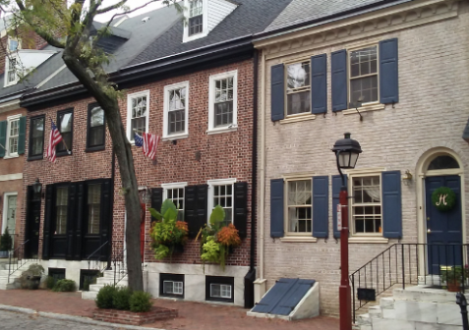 | Rowhouse/Townhouse. This Building type is a small-to medium-sized typically attached structure that consists of 2–8 rowhouses placed side-by-side. This type may also occasionally include detached Buildings with minimal separations between them. This type is typically located within medium-density neighborhoods or in a location that transitions from a primarily Single-Family neighborhood into a neighborhood main Street. This type enables appropriately-scaled, well-designed higher densities and is important for providing a broad choice of housing types and promoting Walkability | 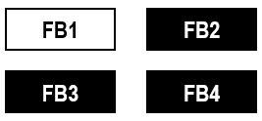
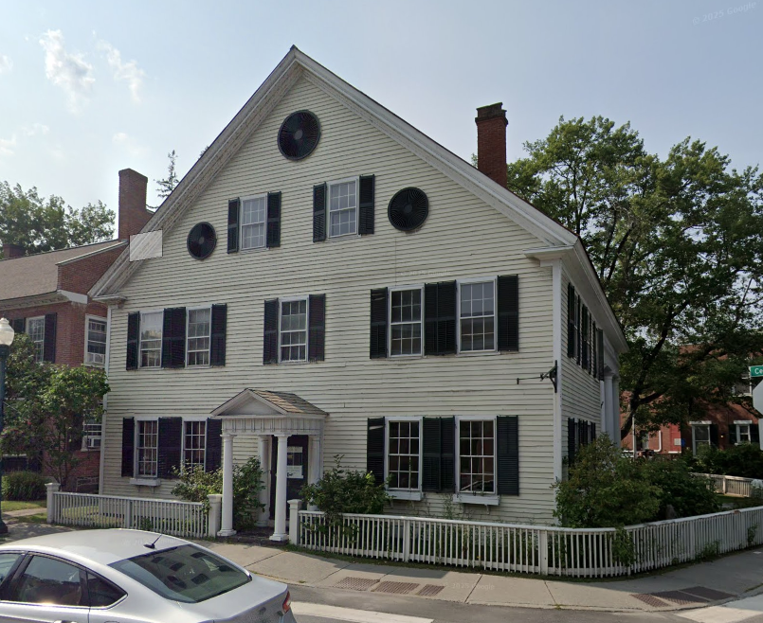 | Main Street Small Office/Commercial Mixed Use. Typical of small town centers, this Building type is a small-scale Mixed-Use structure that presents as an office for real estate, insurance, finance, or similar uses. It is a standalone Building that is appropriate for an area of transition between residential uses and the more intensive town center commercial areas. | 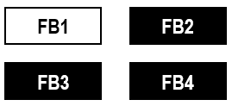
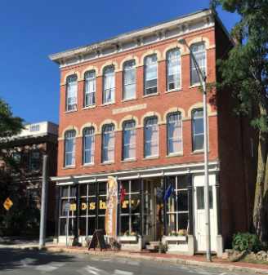 | Main Street Mixed-Use. This Building type is a small-to medium-sized structure, typically attached, intended to provide a vertical mix of Uses with ground-floor Retail or service uses and upper-floor service or residential Uses. This type makes up the primary component of a neighborhood main Street and portions of a downtown main Street, making it a key component of Walkability. | 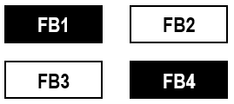
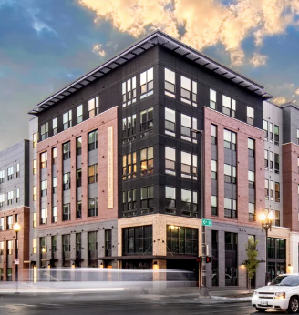 | Mid-Rise. This Building type is a medium-sized structure, 5 stories tall, built on a large lot that typically incorporates structured parking. It can be used to provide a vertical mix of uses with ground-floor Retail, or service uses and upper-floor service, or residential uses. | 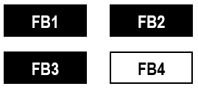
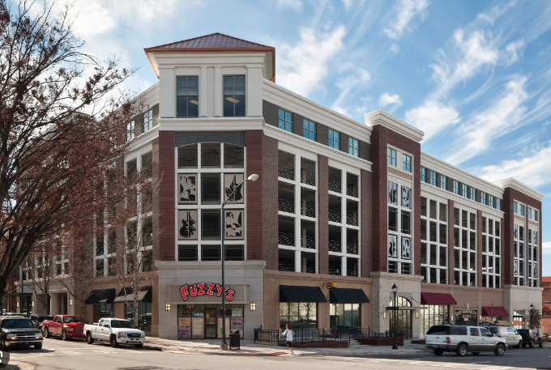 | Liner Building. A Liner Building is a structure, often narrow and/or shallow, built to conceal or shield less visually appealing elements of a Building or site, such as parking areas, service areas, or utility structures, while providing a more aesthetically pleasing Street Frontage. Essentially, it masks or conceals what is behind it. | 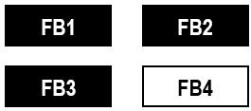

BUILDING STANDARDS

- FAÇADE COMPOSITION

- BASE, BODY AND CAP - The Base, Body, and Cap of a Building communicate height and break the Building into discernible parts to prevent it from being out of scale with the surrounding built environment. Expression Lines can be used to separate each of these components.

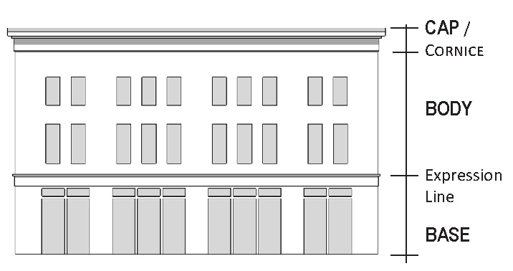
- Expression Lines shall either be moldings extending two inches or more, or jogs of two inches or more in the surface plane of the Building wall.

- A Building mass may be subdivided by Expression Lines into one, two, or three horizontal layers.

- Required Expression Lines:
  - An Expression Line shall be used at the top of any Storefronts. A Storefront Expression Line may consist of a band including a Sign Band.
  - The top of each Building with a Flat Roof must be emphasized with a projecting Cornice that features a deeper projection, and therefore stronger shadow line, than any other Expression Line on the corresponding Façade.

- WIDE FAÇADES

- To maintain visual interest, reinforce compatibility with surrounding context, and avoid monolithic Building appearances, all new Buildings shall incorporate Façade articulation features (e.g., Appurtenances, Façade Types) as provided in Table 3-2 or subdistrict summary tables, that break down massing and enhance the pedestrian experience.
- Façade Length Threshold: Any Building Façade facing a public Street or pedestrian way that exceeds 60’ in length shall be visually divided into two or more increments to reflect the scale and rhythm of traditional Building patterns. No single increment shall exceed 60’ in length.
- Required Modulation Techniques: Façade articulation shall be achieved using any or all of the following techniques:
  - Changes in wall plane with a minimum depth or projection of 12 inches
  - Material or color changes that correspond with a structural bay or vertical break
  - Vertical articulation elements such as pilasters, engaged columns, or projecting bays
  - Variation in roofline, including changes in Parapet height or Cornice detail
  - Recessed Building entrances or Storefronts
  - Regularly spaced bay systems with visible structural rhythm

- Architectural Consistency: All modulation elements shall be architecturally integrated and consistent with a Building’s overall design language, rather than appearing as strictly decorative features.
- Pedestrian Orientation: On Street-facing Façades, modulation elements shall align with ground-level entrances, Storefront divisions, or other pedestrian-oriented elements.

- BUILDING ENTRANCES & ACCESS

- The primary entrance of every Building shall directly face either a Street or a Public Open Space that opens directly onto the Primary Street Frontage.
- Buildings may have more than one entrance.
- Separate commercial spaces located on upper floors shall be accessible via a clearly visible, well-marked ground-level entrance directly from the public sidewalk or main Building lobby and, if part of the same business is located on the ground floor, may be internally accessible from the ground floor.
- Entrances accessible to the public shall be provided at intervals no greater than 50’, unless otherwise approved by the Permitting Authority.
- The design of entrances shall promote cohesion with surrounding architectural character and promote accessibility by providing entrances that communicate how a Building may be entered from the sidewalk. Entrances shall use materials and/or colors consistent with other Façade elements.
- Each entrance shall be articulated as a recognizable focal point through the use of Storefront design, changes in material, canopies, recesses, or similar architectural treatments that define and highlight the entrance.
- Door openings in masonry Façades should include a structural lintel above to express the conveyance of Building weight. A similar method using wood trim can be used on wood-clad Façades.

- ENTRY / EXIT DOORS

Public entrances that swing outward shall be recessed three or more feet deep, measured from the Base, into the Façade

- WINDOW AND DOOR OPENINGS
    - The design of windows shall promote cohesion with surrounding architectural context and reinforce the overall architectural character of the Building.
    - Individual windows on each Façade shall be oriented vertically, meaning that the height of each window shall be greater than the width of that window.
    - When necessary and appropriate to context, horizontally-oriented windows shall be arranged with vertically-oriented windows or doors as a coherent set of windows.
    - Windows on upper floors shall be smaller in size than the modal windows on the ground floor and shall encompass a smaller proportion of the Façade surface area.
    - Windows in masonry Façades should include a structural lintel above to express the conveyance of Building weight. A similar method using wood trim can be used on wood-clad Façades.
    - The top sill of Storefront windows shall be at least eight feet above the adjacent sidewalk.
    - Permanent or retractable security gates, grilles or bars are prohibited.

- MATERIAL CHANGES
- Buildings shall present a coherent and restrained material palette. Material and color changes shall serve a clear architectural purpose, such as highlighting an entry, anchoring a Base, or reinforcing structural rhythm—not simply to add visual variety.
- Excluding trim or accent materials, no more than three material types shall be visible on any single Building Façade.
- Material changes shall wrap around corners, where visible from public Streets or pedestrian paths, to avoid a false-front appearance.
- Changes from one material or color to another along the horizontal direction shall occur at Inside Corner Transitions.
- Changes in material or color along the vertical direction shall occur at a hard-edge Bump-Out Transition.
- High-quality materials such as, but not limited to, brick, natural stone, glass, or masonry, shall predominate. Note that high quality cast stone, or architectural precast concrete with integral color and fine aggregate finish may be permitted. Exterior Building materials shall not include smooth-faced concrete masonry units (CMUs), rough troweled stucco, vinyl siding, synthetic stone veneer, tilt-up concrete panels or prefabricated steel panels, unless the visible finish is brick or stone.
- The overall color palette shall be composed of muted or earth-tone shades consistent with the traditional character of the subdistrict. Exterior colors shall employ matte or low-reflectivity finishes. Highly reflective, fluorescent, or day-glow colors are prohibited.
- Building trim and accent areas may feature any one color not specifically excluded in this subsection provided said color is limited to 10% of the affected Facade segment, with a maximum trim height of 24 inches total for its shortest distance. Neon tubing shall not be an acceptable feature for Building trim or accent areas.

- FRONTAGE TYPES

- Purpose.

The purpose of this subsection is to establish standards for the configuration and design of Building Frontages in order to ensure that new development contributes to a coherent and visually appealing public realm; supports a safe and active pedestrian environment; and reinforces the traditional patterns of streets, blocks, and building forms characteristic of Belmont’s centers and corridors. These standards are intended to promote consistent relationships between Buildings and streets, encourage context-sensitive architectural expression, and align with the purpose and intent of this BCOD. Individual descriptions and form requirements of each Frontage Type are detailed on the following pages.

- Applicability

Any of the three Frontage types may be used in the BCOD as permitted by Table 5-2 unless one is specifically required by the Special Requirements Plan set out in Section 10.3 D.

- Ground Story Active Uses

    - The ground story Commercial Use required by 10.4 D. 1. shall be a Ground Story Active Use, and must occupy at least 70% of the length of the exterior ground floor Façade(s) facing any Street Frontage.

    - The Ground Story Active Use shall have a minimum Ground Story Active Use Depth and View Depth from the front of the Building as set forth in Table 3-2.

    - A minimum of 70% of the length of the exterior ground floor Façade facing any public Street must be comprised of Ground Story Active Uses, as defined in §9.4. For corner lots, both primary and secondary street-facing facades are subject to this requirement.

    - Both the Ground Story and one upper story containing a Commercial Use shall have at least 80% of their Gross Floor Area dedicated to the Commercial Uses rather than lobbies, circulation areas, mechanical rooms, storage not serving either Commercial Use, or other spaces not primarily serving one of the Commercial Uses. No more than 5% of the Gross Floor Area of either floor may be dedicated to storage not serving either Commercial Use.
- Frontage Types Applied

Building Frontages in new construction or to enhance existing buildings should conform with the Frontage Types set forth in this subsection and provided in Table 5.2 below as indicated by the letter “X”. The illustrations and photographs provided are for illustrative purposes only.

Table 5-2 – Appropriate Frontage Types

 | FB1 | FB2 | FB3 | FB4
FRONTAGE TYPES
Storefront | X | X | X | X
Gallery/Colonnade |  | X | X | X
Forecourt |  | X

    - Storefront

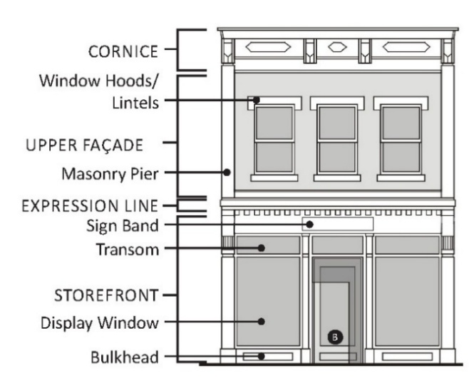 | 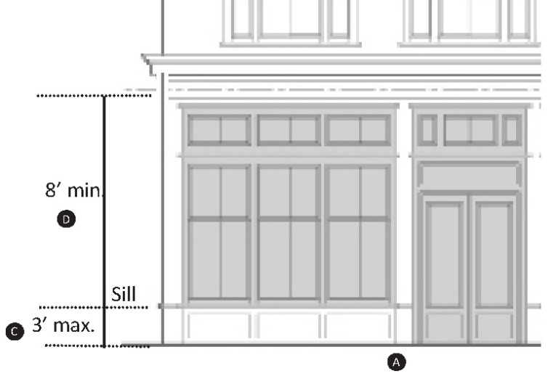
Example Storefront Features

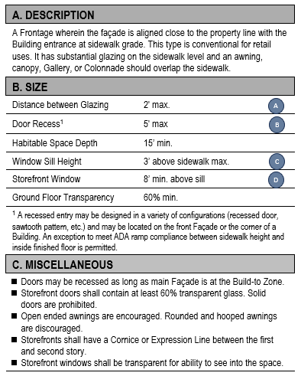 | 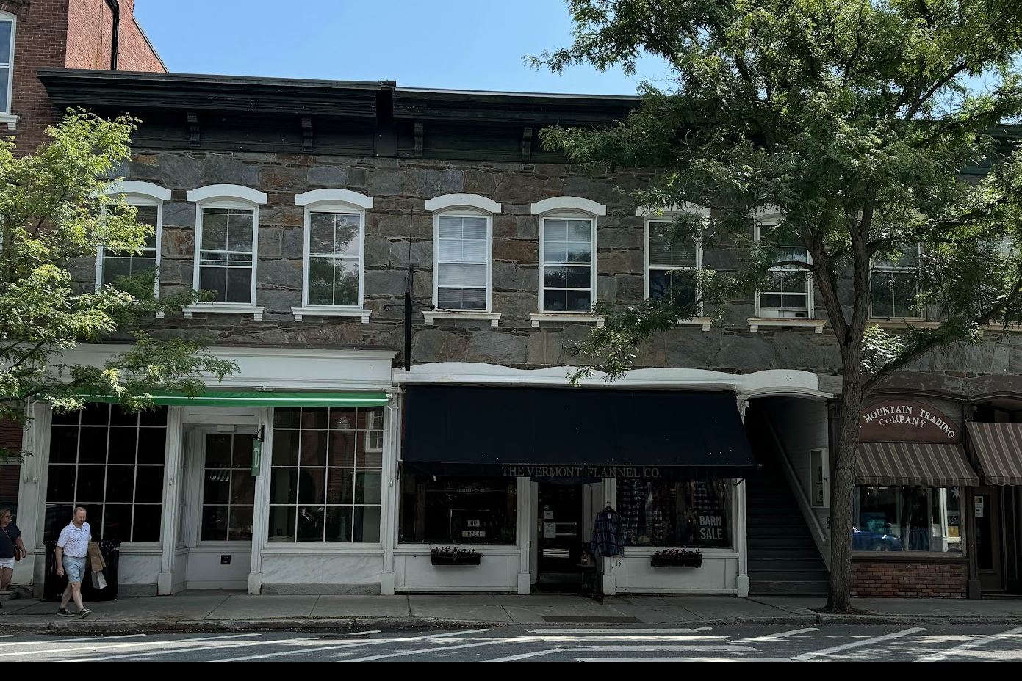
 | 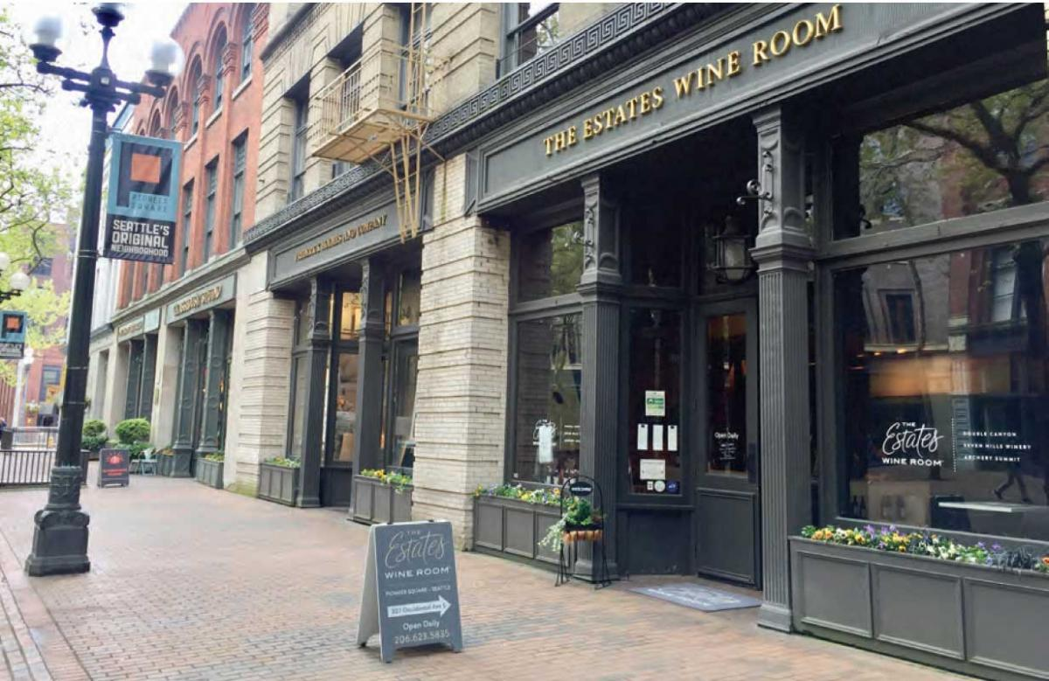

    - Gallery or Colonnade

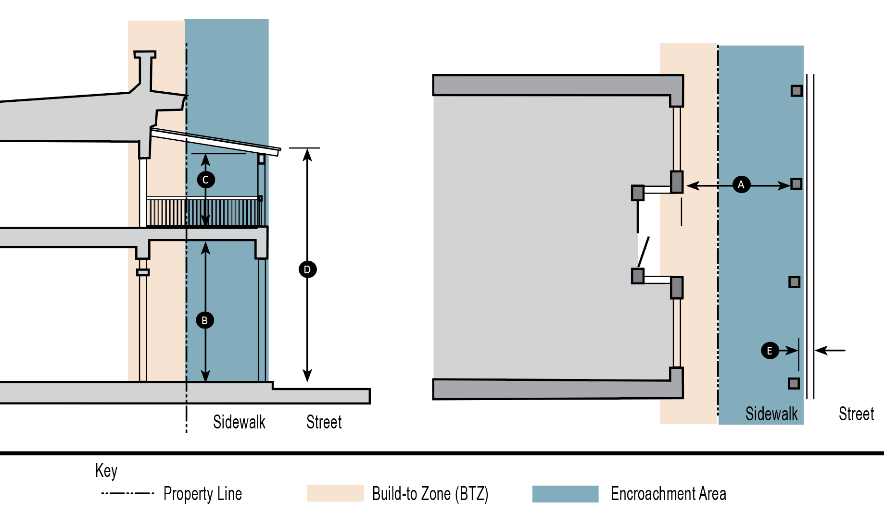
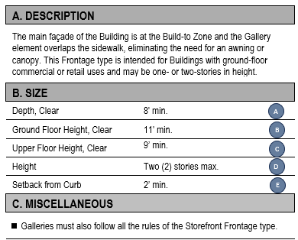
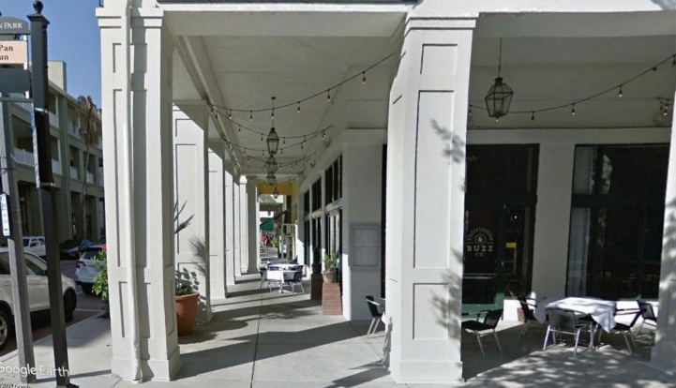

    - Forecourt

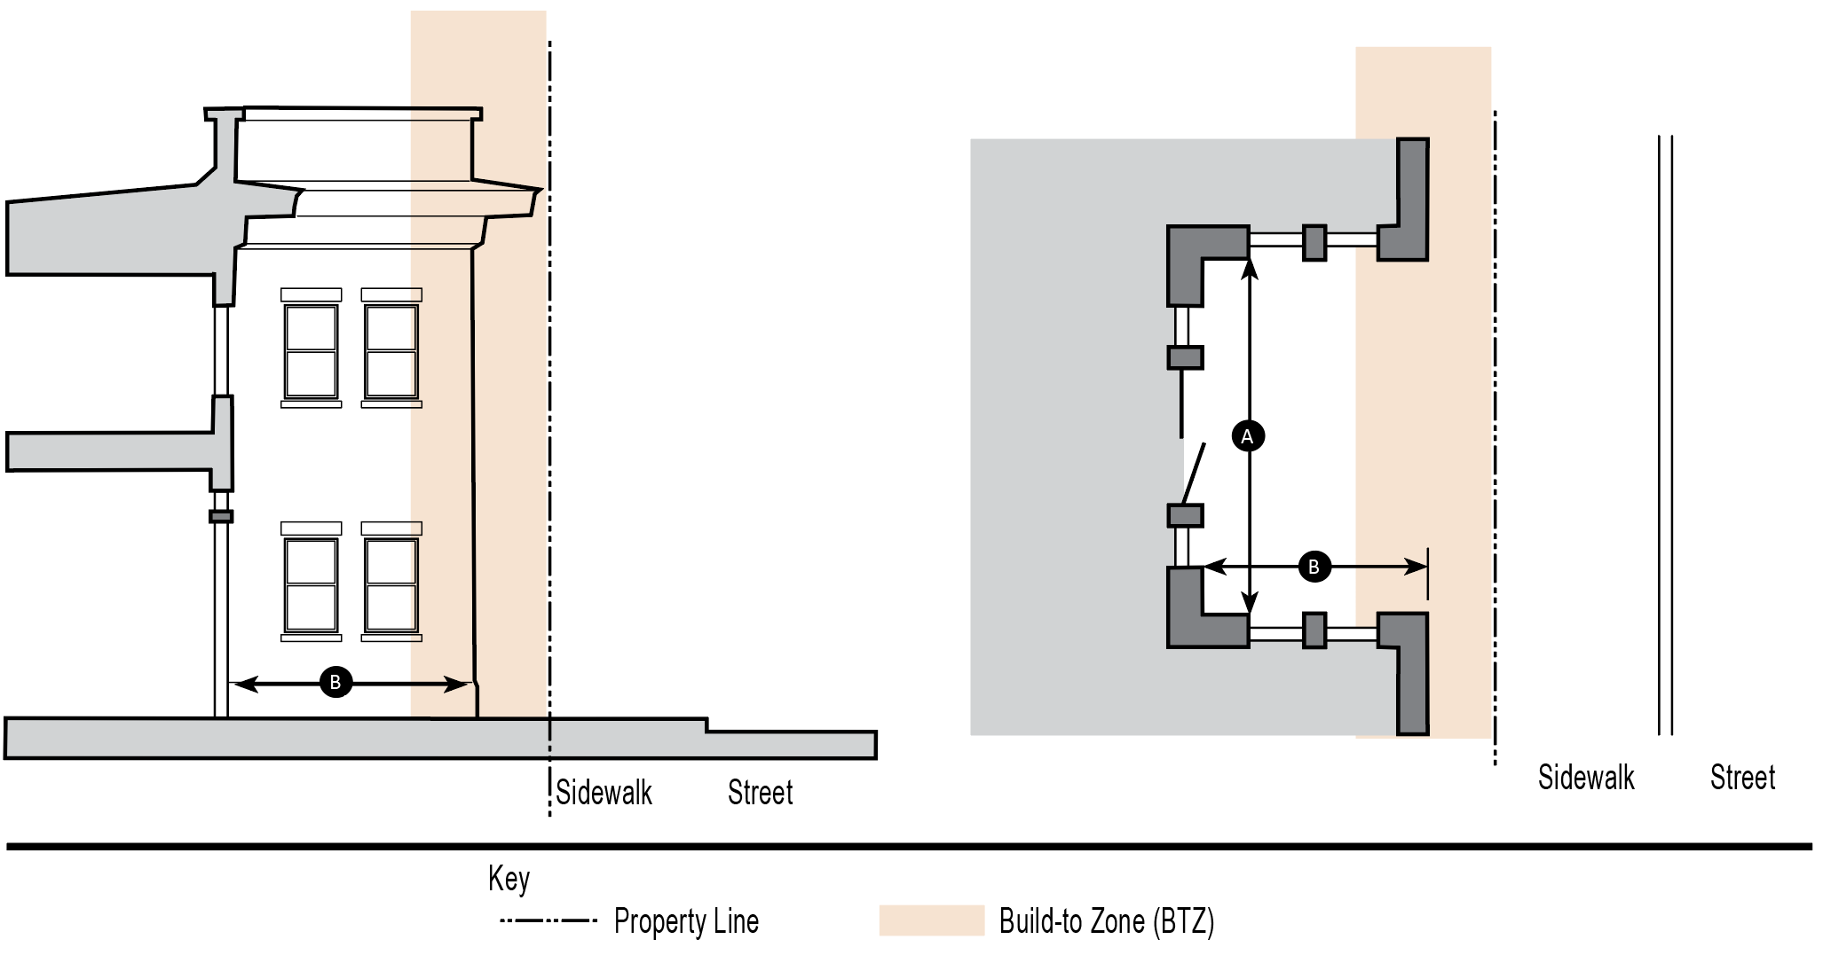
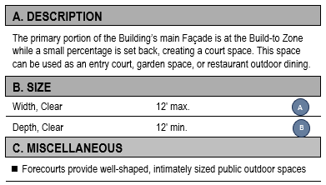 | 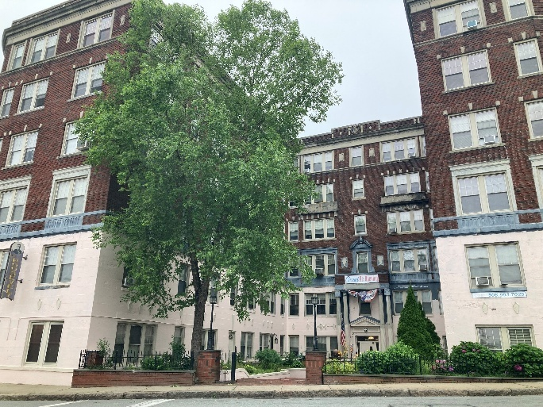

- APPURTENANCES
Each Building with a Storefront Frontage Type shall include three or more complementary Appurtenances to enhance the Frontage’s functionality, identity, and pedestrian experience.
- Appurtenances shall include:
  - Awnings or Canopies
  - Projecting (Blade) Signs
  - Pedestrian-Scale Lighting
  - Outdoor Seating and Dining Elements
  - Bay Windows
  - Display Windows
  - Entry Recesses or Alcoves
  - Planters, Window Boxes, or Hanging Baskets
  - Menu or Service Boards (Restaurants/Cafes Only)
  - Integrated Public Art or Murals

- Appurtenances may encroach within the setback or within the BTZ as per Table 5-3, below, subject to the limits in Table 3-2, above.

Table 5-3 – Appurtenance Requirements

Appurtenance Type | Maximum Projection  from Building Face | Additional Limitations
Bay or Display Windows | May extend up to six feet into required Setbacks and Public Frontages | Combined width may not exceed 25% of the width of the Façade
Galleries, Colonnades, & Arcades | May extend to property line and, subject to Department of Public Works approval, encroach into the Public Frontage | Must remain open to the air on at least one side
Entry Recesses or Alcoves | May extend up to eight feet into required setbacks | Height limited to 2nd story; must remain open (no enclosed square footage)
Awnings & Canopies | May extend up to four feet into Public Frontage as per Sec. 5.25 of the Zoning By-Law. | Minimum 7.5-foot clear height above sidewalk
Planters, Window Boxes, or Hanging Baskets | Up to two feet into required setbacks | No limitation on height, but may not exceed 4 feet in width
Outdoor Seating and Dining Elements | May extend into Public Frontage subject to Select Board approval based on Department of Public Works recommendation | None
Projecting (Blade) Signs | May extend up to four feet into Public Frontage. | Minimum 8-foot clearance above sidewalk; limited to one per business Frontage; may not exceed 12 square feet per face.
Menu or Service Boards | May extend up to one foot into Public Frontage. | Maximum size 6 square feet; must be mounted on Façade or placed on an A-frame within business Frontage; must not obstruct pedestrian travel.
Pedestrian-Scale Lighting | May extend up to three feet into the Public Frontage, subject to Department of Public Works review and Select Board approval if located within a public way. | Must provide a minimum 8-foot clearance above sidewalk level; light fixtures shall be fully shielded, downward-facing, and consistent with the approved Lighting Plan and Design Guidelines.
Integrated Public Art
  None
  May project up to one foot from the Building Facade, or be freestanding within Setback or Public Frontage areas if approved as part of a site or facade plan.
Murals |  | Murals should be on or mounted flush with the Façade.
  Not applicable; murals should be on or mounted flush with the Façade.

- Appurtenances shall not project above the eave or Parapet line of the Building, unless specifically allowed

- An Appurtenance may not cross onto adjacent private property without a recorded easement or comparable instrument so allowing.

- No more than 30% of the total Façade area of a Building may consist of projecting Appurtenances.

- An Appurtenance extending over a public sidewalk or other public way shall be subject to the Town’s right to address resulting safety issues, including removing the offending Appurtenance at the expense of the property owner.
- Awnings, canopies, arcades, Galleries, and Colonnades shall be designed to shelter pedestrians from the elements, create a transition of scale from the Street to the Building entry, reduce heat against the Storefront glass, and provide a distinctive image and identity for businesses in the building. Lighting shall not be directly attached to a canopy or awning.

- FAÇADE TRANSPARENCY REQUIREMENTS
All Building Façades facing onto a Street or public space shall meet these minimum transparency requirements to ensure that there are not blank walls facing a Street and that the Façade supports active Street Frontages, pedestrian engagement, and public safety through natural surveillance.

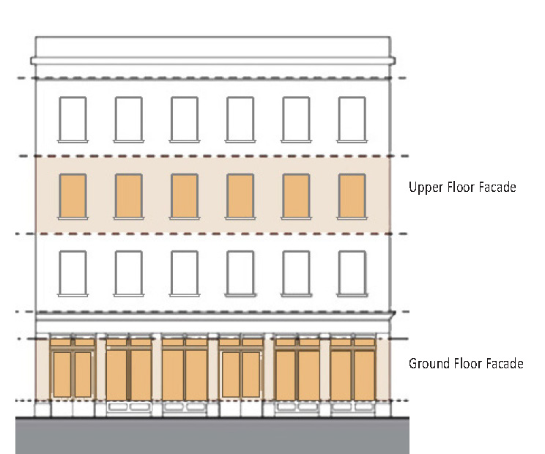
- Ground story Commercial Uses shall have 65% minimum Façade Transparency measured from 2’ to 10’.
- Upper stories shall have 15% minimum Façade Transparency measured from the top of the finished floor to the finished ceiling.

- An Applicant shall provide a diagram to demonstrate compliance with this provision.
- A building that cannot comply with these Façade Transparency requirements shall comply with Section 10.5 D 10, Liner Buildings, instead.

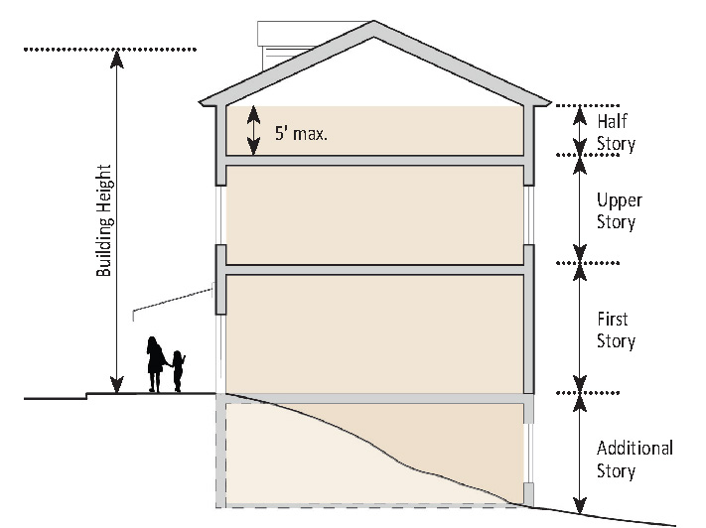
- BUILDING HEIGHT
  - Overall Building Height shall be measured vertically, in stories and in feet, in accordance with the definition of Building Height in Section 10.8.
  - Buildings shall not exceed the number of stories as specified in the Building Dimensional Standards for each subdistrict.
  - When a lot slopes downward from the Front Lot Line, neither cellars nor basements shall count toward the number of stories or Building Height. For the purposes of this subsection, whether a lot slopes downward shall be determined by reference to the existing natural topography prior to any grading or site alteration. Any regrading or excavation intended to create a slope shall not qualify a lot for this provision.
  - Non-habitable roof features such as chimneys, elevator penthouses, rooftop mechanical equipment, railings, and similar projections may exceed the Building Height limit, provided such structures do not exceed 8’ above the eave of the roof or roof deck (if flat). (Refer to Section 10.5 E. 5. b. for mechanical equipment screening requirements.)

  - A Parapet shall not be considered part of the Building Height unless it is designed for occupancy or structural enclosure; exceeds 4’ in height above the highest point of the roof surface, is not used for screening Mechanical Equipment; or exceeds 8’ in height above the highest point of the roof surface, if used for screening Mechanical Equipment.
  - Story Height
    - The Ground Floor of a Building shall comply with the minimum story height requirements specified in the Building Dimensional Standards in Table 3-2 for each subdistrict.
    - The height of the ground story and each upper story of a Building are measured vertically from the surface of the finished floor to the surface of the finished floor above, or to the top of the highest roof beam if no finished floor is immediately above, at all points.
    - The height of a Half-Story is measured vertically from the surface of the finished floor to the top of the highest roof beam above.

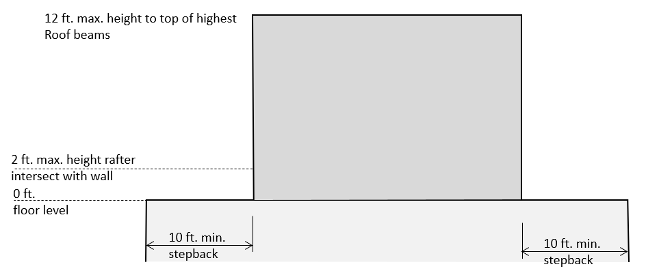

    - Half-Story Step-Back for Flat Roofs
      - The required Step-Back for a half story with a Flat Roof is ten feet.
      - The Step-Back shall be required for any half story on Street Frontages, in a rear yard, or along any Lot Line abutting a residential district. Except as noted in the prior sentence, it shall not be applicable to interior Side Lot Lines.
      - The maximum height of the highest roof beam is 12’.
      - A Half-Story for a Flat Roof may cover no more than 50% of the Footprint.
      - Areas on the Flat Roof but outside of the built half story may be habitable.

- REQUIRED LINER BUILDINGS
A Liner Building is a shallow Building designed to mask the edge of a larger structure like a parking garage or other non-pedestrian friendly use in order to create a more active, attractive, and walkable Street Frontage.

  - The character of some uses of land, such as parking lots or structures, theaters, or grocery stores, may preclude Buildings from complying with the Façade Transparency requirements and detract from Walkability of the surrounding area. Liner Buildings are required in the following conditions:

    - To shield the view of Parking Structures.
    - For new Buildings that cannot meet the Façade Transparency requirements.
  - Liner Buildings shall:
    - Be a minimum of two stories in height and 20’ in depth.
    - Meet the Façade Transparency requirements.
  - Liner Buildings may be used for any use allowed pursuant to Table 4.1 on the lot on which they are located.

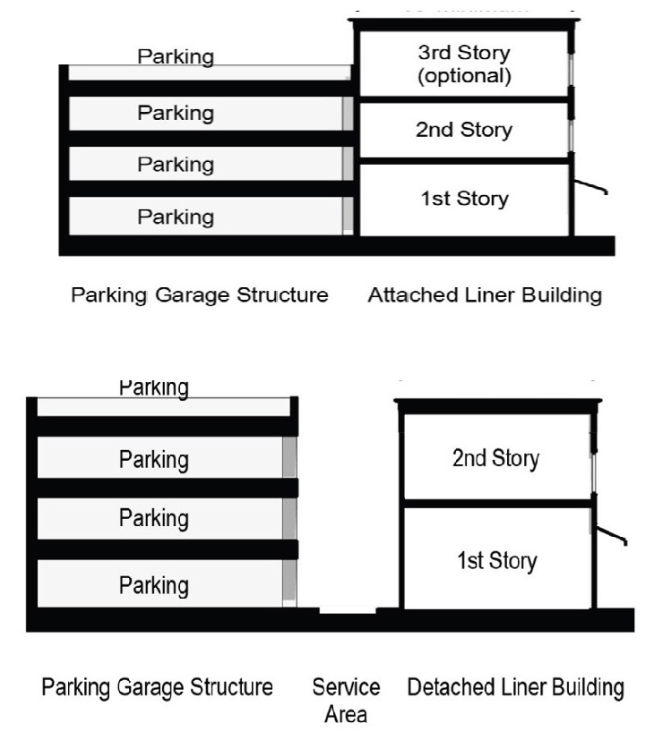
- Micro Storefronts (MiS)
    - Purpose.
The purpose of this subsection is to:

- Create and retain affordable, small-scale spaces for start-up, creative, and entry-level businesses;
- Activate pedestrian areas and enhance the public realm through enhanced Storefront activity;
- Support the arts and creative economy by enabling niche commercial and maker uses;
- Encourage economic diversity and commercial variety in constrained, undersized, or underutilized locations; and
- Provide low-barrier opportunities for entrepreneurship and employment.

    - Applicability.
This subsection applies only to ground-floor commercial spaces meeting all of the following criteria:

- Located within a Liner Building, arcade, or Plaza edge in the BCOD;
- Facing a public sidewalk, pedestrian passage/arcade, or Public Plaza accessible to the general public; and
- Situated where full-scale commercial spaces would be infeasible due to spatial or contextual limitations.

    - Standards.
- Size & Dimensions

- Maximum Gross Floor Area: 500 square feet
- Minimum Depth: 15’
- Maximum Frontage Width: 20’
- Maximum Interior Ceiling Height: 14’

- Form & Design Requirements

- MiS shall utilize a Storefront Frontage type and comply with all applicable ground-story design standards (e.g., height, transparency, entrance spacing).
- When located within an arcade, MiS shall be exempt from ground-floor open space requirements.

- Site Orientation & Access

MiS shall be located on the first floor and have a direct entrance facing a public sidewalk, Plaza, or pedestrian way open to the general public.

- Use & Operations

- MiS shall be occupied by pedestrian-oriented uses such as Pop-Up Shops, Retail, Artisan Manufacturing or Assembly, Art Gallery, and Food Service Establishments.
- Non-pedestrian-oriented uses such as Offices are prohibited.

- Parking

MiS are exempt from all off-Street parking requirements.

- ACCESSORY BUILDINGS

Any accessory building shall have a smaller Footprint, a narrower width, and a depth not greater than that of its associated principal building.

SITE STANDARDS

    - REQUIRED OPEN SPACE

All development shall provide public, semi-public, or private Open Space appropriate to its subdistrict. Open space shall be designed to support the form, scale, and function of the Building and surroundings. Open Space may be at ground level or integrated into the Building design. The design of the Open Space must be approved.

Table 5-4 – Permitted Open Space Types

Permitted Open  Space Types | FB1 | FB2 | FB3 | FB4
Front Yards / Setbacks | Y | Y | Y | N
Courtyards | Y | Y | Y | Y
Rear Yards | Y | Y | Y | Y
Side Yards / Passages | Y | Y | Y | Y
Balconies | Y | Y | Y | Y
Rooftop or Upper Floor Terraces / Gardens | N | Y | Y | Y
Podium Decks or Courtyards | N | N | Y | Y
Public Plazas / Pocket Parks | N | Y | Y | Y
Pocket Parks | Y | Y | Y | Y
Through-Site Connections / Pedestrian Ways | Y | N | Y | Y

- Required Open Spaces may be of the following types, which are permitted in the BCOD as indicated by the letter “Y” in Table 5-4.
- Ground Level Open Spaces:
  - Front Yards / Setbacks: Landscaped or paved with pedestrian amenities. May include seating, public art, planters, or signage.
  - Courtyards: Internal or external spaces, enclosed or partially enclosed by Buildings, that are appropriate for passive recreation or intimate dining areas.
  - Pocket Parks or Public Plazas: see Section 10.6 B.
  - Side Yards / Passages: Narrow spaces between Buildings. May serve as pedestrian connections, garden space, or outdoor dining areas.
  - Rear Yards: Even used for parking, can be bordered by Open Space like green buffers, seating, or Green Infrastructure like rain gardens.
  - Through-Site Connections / Pedestrian Ways: Mid-block walkways that connect front and rear of buildings or adjacent Streets. When left open and landscaped or provided with amenities such as art displays or MiS, these may be considered Open Space.

- Building-Integrated Open Space
  - Balconies off residential spaces.
  - Rooftop Terraces / Gardens, which can be used for social space, amenities, or green roofs (stormwater/ heat reduction). Do not count towards Open Space measurements when dedicated to Commercial Uses such as a restaurant or event space.
  - Podium Decks or Courtyard located above ground-floor parking or Building podiums. Often used for pools, recreation areas, or gathering spaces in Mixed-Use developments.
  - Building Setbacks at Upper Floors that create terrace spaces on multistory buildings.

    - FENCES & SCREENING

- Fences in General
  - All fences along Lot Lines at Streets shall be:
    - Constructed of wood (picket fences with corner posts), masonry, or a combination thereof, or metal.
    - A maximum of two feet in height if the fence is greater than or equal to 80% opacity; or
    - A maximum of four feet in height if the fence has less than 80% opacity or is a masonry knee or retaining wall topped with an open fence (such as picket, scroll, or other style that is architecturally compatible with the structure).
  - All Interior Fences are permitted to measure up to six feet in height. An Interior Fence shall gradually decrease in height as it intersects a street beginning 10’ from the Building setback or street, whichever is greater, down to four feet in height.
  - A fence shall have a smooth or finished side facing away from the Building at which it is installed.
  - Fence posts shall be placed at regularly occurring intervals and fence panels shall be set between the posts.
  - Barbed wire, chain link, chain link with privacy slats, and fences with screening fabric are prohibited.
- Gates
  - Pedestrian and vehicular gates within fences shall be a maximum of 20’ in width, unless a wider opening is required for fire/emergency access, and shall be no taller than the adjacent wall or fence height.
  - Gates shall be constructed of wood, vinyl, or metal.

    - LOADING ZONES
        - On-Street loading and unloading activities shall be conducted from the Street, but not within a sidewalk or bicycle lane, and subject to local traffic and safety regulations. All on-Street loading shall comply with applicable local traffic, safety, and parking regulations. Off-Street loading areas shall be permitted only by Special Permit, and only upon a demonstration that on-Street loading is infeasible due to safety, congestion, or operational constraints.
        - Loading and delivery activities shall occur only between 7:00 a.m. and 10:00 a.m., Monday through Saturday, to minimize disruption to residential, business, and pedestrian activity.
        - Where on-Street loading is required, no off-Street loading docks or service bays shall be permitted.

    - SERVICE AREAS & WASTE ENCLOSURES
- Visibility of Service Areas:

All service areas, including those for waste and recycling, shall be screened to the extent feasible, to minimize visibility from public Streets, sidewalks, parks, and other publicly-accessible areas.

- Waste and Recycling Facilities:
  - Access: Driveways and aisles leading to waste and recycling areas shall remain clear and unobstructed at all times.
  - Screening and Enclosure: All waste and recycling containers shall be fully enclosed and screened from view from the Street or publicly accessible area. Enclosures shall include:
    - A gate or door that can be securely closed;
    - Full screening on all sides; and
    - Placement on a permanent concrete pad.

  - Enclosures shall be at least one foot higher than the tallest container inside, and no more than seven feet in total height.
  - Enclosures shall be maintained to prevent adverse impacts such as noise, odors, and pest attraction and internal containers shall be covered either by a roofed structure or by securely covered receptacles.

- MECHANICAL EQUIPMENT

For the purposes of these standards, Mechanical Equipment shall meet the following requirements.

- Mechanical Equipment shall not be located on or adjacent to a Front Façade if the Mechanical Equipment would be visible from Streets and public spaces.
- Rooftop Mechanical Equipment shall meet the following standards:

  - Rooftop Mechanical Equipment shall not exceed 8’ in height except where it is demonstrably necessary to meet Building or Mechanical Code requirements.
  - All rooftop Mechanical Equipment shall be fully screened from view from adjacent public Streets, sidewalks, residences, and Public Open Spaces. Screening may be achieved by Parapets, architecturally integrated and cohesive penthouses, or coordinated enclosures. Sightline drawings and Street-view photo simulations demonstrating non-visibility at a pedestrian eye height of 5’ to 5.5’ from opposite sidewalks and key corners are required in any Design and Site Plan Review or Special Permit application.
  - Screens shall be cohesive with the architecture and match or complement the Building’s permanent materials, color, and proportion. Perforated screening is permitted only if less than 50% open and still effective at obscuring the screened Mechanical Equipment.
  - Rooftop Mechanical Equipment shall be painted to blend with adjacent or nearby Building materials. However, this requirement shall be applied only so far as feasible and not so as to limit or interfere with the functioning of the equipment.
  - Rooftop Mechanical Equipment shall be grouped and located as far away from roof edges as practicable.
  - Roof features, headhouses, and Mechanical Equipment normally built above the roof and not designed or used for human occupancy shall be included in measuring the Building Height if the total area of such roof features, headhouses, and Mechanical Equipment exceeds in the aggregate: (a) 330 square feet, if the total roof area of the building is 3,300 square feet or less; or (b) 10% of the total roof area of the building, if such total roof area is greater than 3,300 square feet.
- If Mechanical Equipment is located at-grade, and is visible from an adjacent Street or sidewalk, it shall be screened by a fence or enclosure. When equipment is taller than the maximum height of a fence or wall, that maximum height may be waived to allow the height of such wall or fence to match that of the Mechanical Equipment
- If Mechanical Equipment is proposed for a Half-Story, such equipment must either be integrated into the building, placed on the 10’ open Step-Back area, or placed on the roof. In the Step-Back area, it shall be fully screened. If located on a roof, it shall be no higher than 5’ in height and fully screened.
- All Mechanical Equipment or penthouse screening to be placed on the roof shall be set back from the roof line a minimum of 15’. For roofs with an area less than 5,000 s.f., this setback shall be a distance at least equivalent to the height of the screening in order to minimize visibility from surrounding Streets.

REQUIRED SIGNAGE

Commercial Uses on upper floors shall provide clear, visible, and inviting signage at the ground level to identify and promote those businesses. Such signage shall be located on or adjacent to entry doors to upper-level spaces, or in another location that clearly meets these criteria.

PARKING STANDARDS
  - PURPOSE AND INTENT
The purpose of this subsection is to promote efficient and sustainable parking solutions in the BCOD including the use of shared parking facilities, cross-access between lots, and municipal or joint-use Parking Structures. These provisions are intended to reduce the proliferation of individual curb cuts, support Walkability, and optimize land use within the BCOD.

  - APPLICABILITY

These requirements apply to all new development, redevelopment, or Substantial Rehabilitation of existing structures within the BCOD.

  - REQUIRED PARKING

    - Parking shall be provided for each use in accordance with the minimum and maximum requirements outlined by use in Section 10.4, Table 4-1.

    - Fractional Numbers: Except where explicitly stated, if the computation of required parking spaces results in a fractional number, only the fraction of one-half or more shall be rounded up to one.

    - Motor vehicle parking spaces for persons with disabilities shall be provided per 521 CMR 23.00 Parking and Passenger Loading Zones.

    - The Permitting Authority may reduce the minimum parking requirements for a particular lot based on:

      - The special circumstances listed in Section 5.1.1 (b).
      - Transportation Demand Management Plan measures supported by the findings of a qualified independent technical consultant.

    - Parking Satisfaction Sequence
Applicants shall make diligent efforts to meet parking requirements through on-site parking, reductions and waivers pursuant to Section 10.5 G. 3. d., or an approved Shared Parking Agreement pursuant to Section 10.5 G. 5, before seeking to meet parking requirements by having municipal parking spaces credited pursuant to Section 10.5 G. 4.
    - Bicycle Parking shall be provided as specified below:
    - No bicycle parking is required for Ground Story Commercial Uses with five-thousand (5,000) square feet or less of gross leasable floor area, or residential Buildings with three or fewer Dwelling Units.

    - Other non-residential uses shall provide 1 short-term bicycle parking space per 10,000 square feet of gross floor area and 1 long-term Bicycle Parking Space per 2,500 square feet of gross floor area.

    - Multi-family residential (4 Units or more) shall provide 0.60 short-term bicycle parking spaces per Dwelling Unit and 0.10 long-term spaces per Dwelling Unit, rounded up to the nearest whole number.

    - Bicycle parking shall be provided at no fee to customers, visitors, employees, tenants, and residents.

    - Bicycle parking may be provided through any combination of racks and lockers.
    - Bicycle parking serving multiple uses may be combined into a single area or accessory structure.

    - Short-Term bicycle parking shall be provided outside of a Principal Building and within 100’ of the Building served by the parking.
    - Long-Term bicycle parking shall be provided in a well-lit, secure location within the same Building as the use the parking is intended to serve or within an accessory structure located within 200’ of the Building.

  - MUNICIPAL PARKING

    - Purpose

To promote efficient land use, reduce redundant on-site parking construction, and support shared use of Town-managed facilities within the BCOD.

    - Incentivized Use of Municipal Parking Facilities

A project within 500’ of a Town-managed municipal parking lot, Parking Structure, or other parking facility designated by the Select Board for shared use, in a Parking Management Plan or otherwise. may rely on parking spaces in that facility to satisfy up to 100% of their off-street parking requirements. Any project relying on a municipal parking facility to fulfill its off-street parking requirement shall be required as a condition of approval to pay a fee to a designated Belmont municipal parking fund or, if there is none, to the general fund, in lieu of constructing the required off-street parking. The fee shall be computed in accordance with a formula set out in the Planning Board Rules and Regulations or, if the Planning Board Rules and Regulations do not establish a formula for computation of the fee, in an amount to be determined by the Permitting Authority.
An on-street parking space may not be considered a “parking facility designated by the Town for shared use” unless, in addition to any designation by the Select Board, the Planning Board, in consultation with the Department of Public Works and the Police Department, determines that the on-street space is formally managed, signed, and enforced as part of a municipal parking program.

Applicants seeking to use this provision shall identify specific public parking areas or spaces located within 500’ of the project site entrance to demonstrate available capacity and provide evidence, satisfactory to the Permitting Authority, confirming that the identified spaces are consistently available for use by the project. Such evidence may include a parking availability analysis, prepared by a qualified transportation or parking consultant; a utilization study; time-stamped counts; or Town-approved permit data.

The Permitting Authority may approve, conditionally approve, or deny the request based on the evidence provided and any operational or enforcement considerations.

    - Administrative Control of Municipal Parking Allocations

      - Any allocation of municipal parking capacity shall be documented through a written license agreement approved and signed by the Select Board. The agreement shall specify the number of spaces, location, duration, and time-of-day conditions of use; shall be non-exclusive and revocable for cause; and shall require payment of any fees established by the Town for maintenance or replacement of public parking supply. The Select Board shall sign such an agreement only upon finding that in the applicable municipal facility has adequate unallocated capacity at the time of approval determined by the Town’s most recent utilization study or ledger maintained by the Office of Planning and Building. No new license shall be issued if the combined allocations would cause the total committed spaces to exceed available capacity during the relevant peak period.

      - Each license agreement shall be reviewed at least once every five years, or more frequently if required by the Select Board, to confirm that the project’s use of municipal parking capacity is consistent with the license. If the use of municipal parking capacity exceeds what the license authorizes, the project shall be considered in violation of its Design and Site Plan Approval or Special Permit, as applicable.

      - If a license agreement is revoked or otherwise terminates, the project owner must take steps to ensure that the project has sufficient remaining parking including, as applicable, by applying to amend its Design and Site Plan Approval or Special Permit, as applicable. So long as the project owner is acting with reasonable diligence to obtain such an amendment, the project shall not be considered in violation of its Design and Site Plan Approval or Special Permit by reason of having insufficient parking.
  - SHARED PARKING ON PRIVATE LOTS

- Purpose

To encourage efficient land use and minimize redundant parking by allowing uses with compatible demand periods to share adequately-sized off-street parking areas within the BCOD.

- Eligibility and Location
Shared or joint-use parking facilities may serve uses on multiple different properties and located within 500’ of each other and the parking facilities, provided that adequate, legal, and convenient pedestrian access is ensured.

- Shared Parking Agreements
Participants shall execute a Shared Parking Agreement, recorded at the Middlesex North Registry of Deeds prior to issuance of a Certificate of Occupancy, specifying:

- Participating owners and properties;
- Number, location, and time-of-day allocation of spaces;
- Maintenance, lighting, snow removal, and liability provisions; and
- A minimum term of ten years or the duration of the uses served, whichever is longer.
- That the agreement may not be modified or terminated without Permitting Authority approval demonstrating the projects continued compliance.

- Demand Calculation and Approval Criteria

The Planning Board shall establish in its Rules and Regulations a Shared Parking Occupancy Factors Table based on the Urban Land Institute (ULI) Shared Parking Manual or the Institute of Transportation Engineers (“ITE”) Parking Generation Manual. The Planning Board may adopt further Rules and Regulations concerning the determination of the number of parking spaces required for combined or complementary uses.

Required spaces shall be determined by either:

- The Rules and Regulations of the Planning Board; or
- A professional parking study demonstrating equivalent or lesser total demand.

The Permitting Authority shall approve a Shared Parking Agreement when the combined peak-hour demand does not exceed available spaces. Such an Agreement shall show that each principal use will have adequate access to the shared facility and that the shared facility otherwise meets the requirements of this subsection.

- Design and Performance Standards
Shared parking facilities shall:

- Provide clear, safe pedestrian pathways to Building entrances;
- Include appropriate lighting, signage, and landscaping;
- Comply with all applicable MAAB and safety standards; and
- Demonstrate continued functionality and enforcement consistent with any municipal or other professional parking management program or plan.

- Coordination with Municipal Parking
Where shared-use facilities involve or connect to Town-managed municipal lots or structures; operational terms shall be governed by Section 10.5 G. 4.

  - ACCESS BETWEEN LOTS AND CURB CUT REDUCTION

    - Cross-Access Requirement

All new development or redevelopment shall provide internal vehicular and pedestrian connections to lots adjacent to each Building to facilitate access to shared parking areas. Easements for cross-access shall be filed with the Town Clerk and recorded at the North Middlesex Registry of Deeds and maintained in perpetuity.

    - Curb Cut Minimization

- Up to one project under this Section 10 may add a new curb cut within the FB2 subdistrict to provide access to a single Porte Cochère designed as a shared drive.
- Up to one project under this Section 10 may add a new curb cut within the FB3 subdistrict to provide access to a single Porte Cochère designed as a shared drive, provided that no pedestrian passage is otherwise provided at that location.
- On all other streets, new curb cuts shall be limited to the minimum necessary for safe access. Where feasible, developments shall utilize existing curb cuts or access points from adjacent properties through cross-access easements.

    - Consolidation of Access Points

When adjacent lots are under common ownership or control, drives allowing access from the Street shall be consolidated to the maximum extent feasible.

    - Dimensional and Placement Criteria for Porte Cochère:
- Location
  - A Porte Cochère may only be located where expressly permitted by this Section 10.
  - When located on a Primary Street Frontage, the opening shall be placed mid-block unless another location would significantly reduce conflict with pedestrian crossings.
- Width
  - Maximum clear width of the vehicular opening shall be 20’ for one-way traffic and 26’ for two-way traffic.
  - The total Façade opening width along the Street Frontage shall not exceed 25% of the Building’s Frontage length.
- Height.
- Minimum clear height shall be 12’.
- Maximum clear height shall be 16’ unless a taller clearance is required for emergency vehicle access.
- Building Integration
  - When located through a Building, it shall be architecturally integrated into the Building massing and Street Façade, with upper floors continuing above.
  - Street-facing openings shall be treated with architectural detailing (e.g., arches, lintels, columns, or other façade treatments) to maintain pedestrian-scale Frontage.
- Standalone Structures
- When freestanding, it shall be subordinate to a Principal Building and mainly located in the side or rear yard.
- Design features, including roof fo’
rm, materials, and detailing, shall be consistent with the Principal Building.
- Pedestrian Accommodation
- A sidewalk at least 6’ in clear width shall be maintained continuously across the Frontage of a Porte Cochère opening.
- Pedestrian entrances and passageways shall not be obstructed by vehicular use of the Porte Cochère.
- Access
- All Porte Cochères shall operate as low-speed access drives, with traffic signage or pavement markings as necessary.
- Shared access with adjoining properties is encouraged where feasible.
  - DESIGN STANDARDS FOR STRUCTURED PARKING
    - Structured parking facilities shall be designed to:
      - Provide clear pedestrian pathways to Building entrances.
      - Include appropriate lighting, signage, and landscaping.
      - Meet all applicable ADA and safety standards.
      - Intent and Generally
        - Parking areas can degrade the public realm by interrupting human-scaled spaces with inactive automobile-scaled spaces. Standards in this subsection provide functional parking techniques to minimize the impact of automobiles and Parking Structures on the public realm.
        - Parking Structures with multiple levels above ground require either Ground Story Active Uses including Liner Buildings or architectural screening to maintain an engaging streetscape.
- Entrances
  - Openings
    - Entrances to parking and service areas shall occur on a side Street.
    - Entry gates shall be set back a minimum 10’ from the Building Facade and a minimum 20’ from any vehicular travel or parking lanes.
    - Facade opening(s) for entries to parking areas shall not exceed 22’ in width.
    - Entrances wider than 20’ shall have a column or permanent divider separating the entrance into two openings, each covered with separately operating garage doors.
    - Facade opening(s) for entries to parking areas shall align with Façade Composition requirements set out in Section 10.5 D. 1.
  - Garage Door Standards, As Applicable
    - Garage Doors must be made of solid materials that meet the standards of Section 10.5 D. 5 and are compatible in color and material with the main body Building Facade;
    - Windows may be back-lit but shall cover or obscure any light source or fixtures to reduce glare and create the appearance of a traditional window of an occupied space.
    - Illumination is limited to hours of operation or, if 24 hours facility, no later than 10:00 p.m. unless acting on a censor that only illuminates when necessary.
  - Grading - The grade of the driveway within 20’ of the Lot Line shall not exceed 10%.
- Above-Ground Standards
  - Natural or mechanical ventilation for structured parking areas at grade shall minimize visual impact on residential districts.
  - Facade opening(s) for entries to parking areas shall align horizontally with adjacent architectural articulation(s) and/or Facade opening(s).
  - Any exterior edge of a Parking Structure shall be screened by an exterior wall and a Liner Building in the applicable locations. Openings to Parking Structure shall comply with Section 10.5 D(4).
- Subterranean Standards - Subterranean parking shall not exceed 4’ above the Finished Grade of the adjacent Building and shall be in compliance with zone setbacks, Building form, and Frontage type standards.

LIGHTING STANDARDS

Lighting standards protect against glare, preserve the dark sky, minimize impact on abutting residential districts, and reduce unnecessary energy use from overlighting.

- GENERAL LIGHTING STANDARDS

  - A streetlamp shall be of the same style as the existing poles and fixtures along the block on which it is located.
  - Light Fixtures shall be downcast or shall be low cut-off fixtures except where otherwise specified.
  - Energy efficient lamps shall be used for all Light Fixtures.

- PEDESTRIAN WALKWAY LIGHTING
  - Pedestrian walkway lighting, either as a standalone fixture or mounted to poles, shall be installed at a mounting height between 12’ and 16’, measured from Finished Grade to the light source, and be consistent within a block, and preferably a subdistrict. Mounting height must be between 12’ and 16’ except as set forth in the following sentence. Mounting heights up to 18’ may be authorized by the Permitting Authority at intersections or mid-block crosswalks to achieve lighting uniformity, provided pedestrian-scale fixtures are maintained along the block face.
  - Light Fixtures located along pedestrian walkways adjacent to parking lots shall not exceed 15’ in height.
  - Light Fixtures located between buildings and not adjacent to a parking area shall not exceed 10’ in height.
  - Pedestrian walkway lighting shall not exceed 4000K in temperature.

- PARKING LOT LIGHTING
  - All fixtures shall be full cutoff and downward facing.
  - Light Fixtures located within the asphalt area of a parking lot shall not exceed 30’ in height. Light Fixtures located along the perimeter edge of a parking area within 50’ of a property line shall not exceed 15’.

- BUILDING AND SECURITY LIGHTING
  - All exterior Building or security lighting shall be full cutoff, shielded, and/or angled downward to focus the light only on the intended doorway or walkway.
  - Security lighting shall consist of regular pedestrian Light Fixtures where visible from the Street or public way.
  - Business owners shall leave display window lighting on at night and may leave other interior lighting on. However, lighting shall be designed in such a way as to minimize the direct view of the light source from within neighboring residences.
  - No LED strip lighting shall be used in window frames or on architectural details.

LANDSCAPE STANDARDS
  - REQUIRED LANDSCAPING
        - The standards in Section 5.3 shall apply, except as modified below.
          - Landscape buffer areas between Lots required for side property boundaries are not required between subdistricts.
          - The landscape buffer required between commercial properties and residential properties is required in the FB2 subdistrict only.

      - ADDITIONAL STANDARDS
        - Where applicable, Building Setbacks shall be adjusted to preserve existing native tree canopies.
        - Use of trees to provide shade, color, and interest, and use of vines or trained plant materials is appropriate.
        - Maintenance. All fences, trees, plantings, shrubbery or other screening required by the Belmont Zoning By-Law shall be maintained at all times at least to the same quality required of said items at the time they were initially installed.
        - Detention and Retention Areas. Detention and retention areas should be designed without fencing and in a manner that does not call attention to their stormwater management function.

STORMWATER MANAGEMENT STANDARDS
  - GENERAL REQUIREMENT
All development and redevelopment projects shall meet the requirements of Section 7.3.4(d) of the Zoning By-law with respect to Stormwater Management and Erosion Control.

  - GREEN INFRASTRUCTURE / LID PRIORITY
Stormwater management shall prioritize Green Infrastructure and Low Impact Development (LID) strategies before considering traditional gray infrastructure. Applicants shall consider the following practices:
          - Bioretention areas (rain gardens)
          - Permeable pavement
          - Green roofs
          - Street trees with structural soil
          - Vegetated swales
          - Cisterns or rain barrels

If the Applicant demonstrates that these strategies are infeasible or insufficient to achieve compliance with the Stormwater Management and Erosion Control Bylaw, the Permitting Authority may grant a waiver permitting the Applicant to use traditional gray infrastructure to the extent needed.

The Permitting Authority may grant any waivers reasonably required to enable the use of shared or district-scale Green Infrastructure.

  - ON-STREET AND PUBLIC REALM INTEGRATION
Where feasible, stormwater management features such as curb extensions, landscaped bump-outs, or infiltration planters should be designed as integral elements of sidewalks, medians, or furnishing zones, consistent with Complete Streets principles. All such installations shall maintain required pedestrian clear widths and comply with applicable accessibility and safety standards.

  - MAINTENANCE
All Green infrastructure systems shall include a maintenance plan to ensure long-term functionality and shall be maintained by the property owner, business improvement district, or a designated public entity.

TRANSPORTATION DEMAND MANAGEMENT REQUIREMENTS

The Permitting Authority shall consider whether to retain a qualified independent technical consultant to review any Application to make recommendations concerning the necessity and nature of transportation demand management measures.

CONSTRUCTION MANAGEMENT REQUIREMENTS

The Permitting Authority shall consider whether to impose as a condition of approval for any project under this Section 10 that the project have a construction management plan approved by the Inspector of Buildings before the beginning of construction, and may consider imposing other conditions to mitigate anticipated disruption to access, safety, or business operations within the geographic limits of the BCOD due to simultaneous construction activities or maintenance of the Street.

§ 10.6 STREETS AND PUBLIC OPEN SPACES

STREETS AND SIDEWALKS

  - All projects shall conform to Section 60-800 of the General Bylaws and any other applicable Town bylaws, regulations, or rules governing the layout and use of public and private ways.
  - The Street Hierarchy, from highest-priority to lowest-priority, shall be as follows: Leonard Street; Claflin Street; Concord Avenue; Moore Street, Channing Road, and Alexander Avenue.

PUBLIC OPEN SPACES

    - New Public Open Spaces may be either Plazas or Pocket Parks, based on the BCOD subdistrict as indicated by the letter “X” in Table 6-1.
    - Any new Public Open Space shall meet the requirements in Table 6-2 Open Space Type Requirements.
    - All Public Open Spaces shall be at grade level and shall be accessible to the public at posted times.
    - The ground level of a Public Open Space shall be a combination of paving, lawn, or ground cover integrated in design with trees and shrubs. Fountains, sculptures, and works of art are encouraged. Plantings or fixtures shall not obstruct sight visibility triangles at Street intersections.
    - Stormwater management improvements shall be integrated with the final landscape design as aesthetically and visually pleasing design elements.
    - Whenever possible, landscape design shall promote sustainability awareness and education through interpretive signs, demonstrations, and other displays.

PLAZA  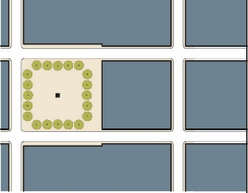 | A Plaza is a predominantly hardscaped Public Open Space located adjacent to high activity commercial or Public Buildings. Plazas are typically paved and furnished with seating, lighting, and landscaping elements such as planters or trees. They are designed for heavy, active pedestrian use, casual gathering, and programmed events like performances or markets.
POCKET PARK  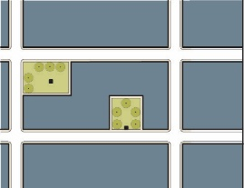 | A small (typically less than 5,000 s.f.) landscaped Public Open Space intended to provide space for quiet, passive resting, gathering, and socializing. Pocket Parks are intended to be nestled between town center buildings or spaces where there is not sufficient space for a Building or structure.

Table 6-1 – APPROPRIATE PUBLIC OPEN SPACE TYPES | FB1 | FB2 | FB3 | FB4
Plaza |  | X | X | X
Pocket Park | X | X | X | X

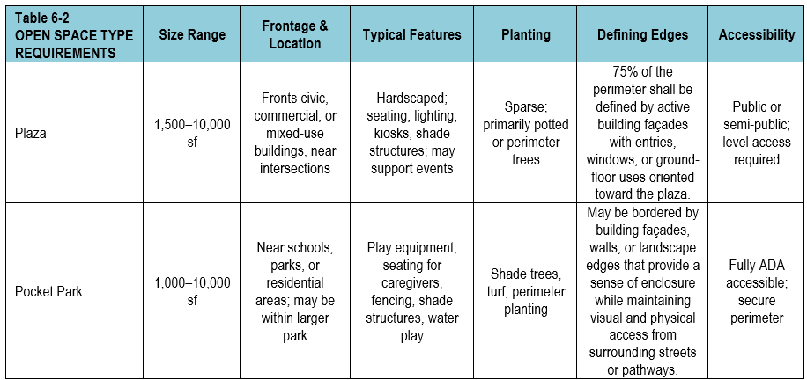

§ 10.7 ADMINISTRATION

GENERAL ADMINISTRATION

  - The provisions of Section 7, Administration, shall apply to developments within the BCOD except as amended, supplemented, or superseded in this Section 10.

  - Authority to Establish and Amend Regulations, Scope, and Criteria. The Planning Board shall establish and may periodically amend Rules and Regulations relating to the administration of this Section 10, including additional regulations relating to the scope and format of Applications and reports required hereunder.

  - Fees

    - The Planning Board shall establish and may periodically amend a schedule of fees for all Applications under this Section 10, which may include review fees for legal advertising and public notice signs and technical review fees. No Application shall be considered complete unless accompanied by the required fees.

    - Application fees are not refundable if an Application is withdrawn after public notice.

  - Technical Review Fees.
    - Pursuant to G.L. c. 44, § 53G, and in accordance with the Rules and Regulations established by the Planning Board, the Permitting Authority may engage the services of qualified independent technical consultant(s) to review any Application.

PROCEDURES
  - Submittal of Application and Application Completeness

  - The Applicant shall file any Application in accordance with Section 7.3 or 7.4, as applicable, of this Zoning By-Law, and the Rules and Regulations of the Planning Board. The Rules and Regulations of the Planning Board may supplement or supersede the requirements set out in Section 7.3 or 7.4 with respect to the contents, form, or submission procedures for any Application to develop a project under this Section 10.

  - Any Application for a project under this Section 10 shall clearly state that the applicant is proceeding under this Section 10.

  - The Inspector of Buildings shall certify the date and time any Application is received.

  - Once an Application is determined by the OPB Director or their designee to be complete, the staff or the Permitting Authority may request additional information or data to determine compliance with the requirements and intent of this Section and applicable portions of the Base Zoning.

APPLICATION REVIEW & STAFF REPORTS

In addition to any requirements set out in Section 7 for staff to review an Application and provide information to the Permitting Authority, the OPB Director or their designee shall report on any Application as follows.

      - The OPB Director or their designee shall provide an initial written report on the Application to the Permitting Authority at least five days before the opening of the public hearing on the Application and present the report at the outset of the public hearing. The report shall address conformance with Town by-laws, regulations, and review criteria, and any areas of impact where the reporter recommends further analysis, additional data, or referral to technical review.

      - The Permitting Authority may require the OPB Director or their designee to provide a follow-up report on any compliance, impact, or safety issues, or any conditions or mitigation measures recommended for inclusion in the Permitting Authority’s decision. The follow-up report does not serve as the approval of final drawings for the issuance of a Building Permit.

STANDARDS FOR COMPLIANCE AND REVIEW CRITERIA
In addition to any applicable requirements and standards the Permitting Authority may or must apply pursuant to Section 7.3 or 7.4 of the Zoning By-Law, the Permitting Authority shall review the Application to ensure conformity with the provisions of Section 10, including the following:

          - Section 10.3. A., Form-Based Overlay Districts
          - Section 10.5 D., Building Standards.
          - Section 10.5 D. 6., Frontage Types, as applicable
          - Section 10.5 E. 1., Required Open Space
          - Section 10.5 G., Parking Standards
          - Section 10.5 I., Landscape Standards
          - Section 10.5 J., Stormwater Management Standards
          - Section 10.5 E. 2., Fencing & Screening
          - Section 10.5 E. 5., Mechanical Equipment
          - Section 10.5 G. 7., Design Standards for Structured Parking
          - Section 10.5 H., Lighting Standards
          - Section 10.5 E. 4., Service Areas & Waste Enclosures

No project shall be required to have a concept plan approved in accordance with Section 3.5, Major Developments.

§ 10.8 DEFINITIONS

As used in this Chapter, the following terms and phrases shall have the meanings indicated. These definitions apply only to projects under this Section 10. Terms or phrases not defined in this subsection but defined in Section 1.4 shall have the meaning provided in Section 1.4. Terms shall mean as defined regardless of capitalization.

A DEFINITIONS

APPLICATION - An application for Design and Site Plan Review or a Special Permit in accordance with this Section 10.

APPURTENANCES - Porches, balconies, patios, canopies, awnings, and similar frontage elements, which extend outward from the Facade of a Building. For the purposes of measuring setbacks and Build-to Zones, Appurtenances are not part of and do not count towards the Facade itself.

ARTS EXHIBITION AREA - A Building lobby, part of a lobby, or other publicly accessible space on the basement or first or second floor of a Building, or an outdoor public area on private property, designed and used for the public display and sale of works of art.

ART GALLERY – A use of a building or portion thereof for the exhibition and display of original or limited-edition works of visual art for public viewing, and which may include the sale of such works, but does not include the on-site creation of art as a principal Use.

ARTISAN MANUFACTURING OR ASSEMBLY - The on-site production of goods by hand, or with the use of small-scale, light Mechanical Equipment, where the manufacturing process has minimal impact on surrounding properties. This includes activities like woodworking, glass blowing, metalworking, ceramics, and jewelry making. An Artisan Manufacturing and Assembly includes commercial art studios, and other arts or crafts and similarly scaled avocations. Such facilities are limited to 3,500 s.f. for single enterprises and 7,000 s.f. for shared, co-working spaces.

B DEFINITIONS

BASE – The lowest portion of a Façade that intersects the sidewalk. It visually “anchors” the building, typically contains the Storefront/entry level, and is often differentiated by heavier materials, greater transparency, and pedestrian-scaled detail. In tripartite composition, this is the bottom zone of the elevation.

BASE ZONING – The zoning requirements established in the Belmont Zoning By-Law, other than the requirements in Section 9, Section 10, or any other opt-in overlay district, for any given Lot.

BASE ZONING DISTRICTS – The zoning districts established in the Base Zoning.

BODY – The central portion of the Façade above the Base and below the Cap. It is usually made up of the repetitive upper stories with a consistent window rhythm and simpler articulation that ties the composition together. In tripartite composition, this is the middle zone of the elevation.

BROADCAST MEDIA STUDIO - A studio space dedicated to the recording or production of audio and/or visual art forms or the broadcast via radio, television, internet or other media of audio and/or visual art forms, or the combination of any of the above, provided that one of the following criteria is met: that it has at least 200 s.f. of space; that is has at least one non-resident employee; or that it receives client visits or regular dedicated deliveries, requires signage, or exceeds the noise requirements in the General Bylaws.
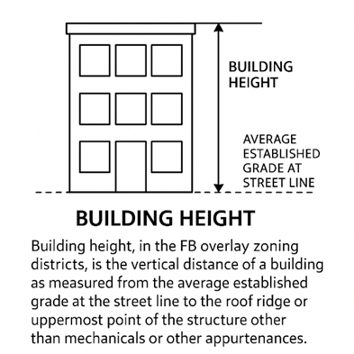

BUILDING HEIGHT - The vertical distance of a Building as measured from the average established grade measured along all Street Frontages to the roof ridge or uppermost point of the structure other than Mechanical Equipment or Appurtenances.

BUILD-TO ZONE (BTZ) - A designated area on a lot, measured as a range of distances from a Street Lot Line or Frontage line, within which the Façade of a Building is required to be located..

BUMP-OUT TRANSITION – The point of transition between the main wall of the Building Façade and a portion of the Building Facade that projects outward, creating a “bump” or extension from the main plane of the wall, often used to highlight a specific feature, such as a bay window, entryway, or decorative element.

C DEFINITIONS

CAP – The uppermost portion of a Façade that terminates the Façade against the sky. It may include a pronounced Cornice or Parapet, slimmer upper banding, or roof forms that “crown” the composition and complete the vertical hierarchy. In tripartite composition, this is the top zone of the elevation.

COLONNADE – Refer to definition of Gallery below.

COMMERCIAL USE – Retail, service, office, and other non-residential uses intended as a business enterprise and listed in Table 4-1 of this Section 10.

CORNICE - Projecting horizontal decorative molding along the top of a wall or Building.

CRAFT BEVERAGE ESTABLISHMENT - An establishment licensed to manufacture alcohol under G.L. c. 138 that produces less than 465,000 gallons (or 15,000 barrels) on-site per year for consumption on or off premises, including craft breweries, microbreweries, cideries, meaderies, distilleries, and wineries.

E DEFINITIONS

EXPRESSION LINE - A horizontal line created by a change of materials or by a continuous projection no less than two inches deep.

F DEFINITIONS

FAÇADE (OR FACADE) - As defined in Section 9.4 L.

FAÇADE TRANSPARENCY - The proportion of the surface area of a Building’s Façade made up of transparent window glass or other openings.

FAÇADE, FRONT - The Façade of a Building that faces a Front Lot Line.

FENCE, INTERIOR – A fence along a Lot Line shared with another Lot and not located along a Street.

FENESTRATION - The openings in the Façade of a Building, including windows and doors. Fenestration is measured from the inside face of the jambs on any window or door trim but excluding non-transparent parts such as lintels, frames, sills, transoms, and mullions, but including window parts such as muntins if they are less than an inch wide.

FINISHED GRADE - The surface of the ground after completion of any change in contour, if any; otherwise, the natural surface of the ground.

FLAT ROOF – A roof with a pitch no greater than 2%. A Flat Roof shall include a Parapet wall to ensure safety and fire protection, as well as for aesthetics.

FOOTPRINT – Means the same as “Building Footprint,” as defined in Section 9.4 F.

FORECOURT - The space created when the primary portion of a Building’s Front Facade is at the BTZ while a small percentage is set back. This space can be used as an apartment entry court, garden space, or for outdoor dining.

FRONTAGE - The area between a Building Façade and a Front Lot Line, including the area’s built and planted components.

FRONTAGE BUILDOUT – Means the same as “Façade Buildout Ratio,” as defined in Section 9.4 M.

FRONTAGE, PRIMARY STREET – The Frontage along the Primary Front Lot Line, as defined in Section 9.4 DD.

FRONTAGE, PUBLIC - The area between a Lot Line and vehicular travel or parking lanes.

FRONTAGE, SIDE STREET – Frontage, other than the Primary Street Frontage, along a Street.

FRONTAGE, STREET – Any Primary or Side Street Frontage.

G DEFINITIONS

GALLERY – A surface projecting from the Front Façade of a Building, and overhanging a portion of the Build-to Zone that overlaps with the sidewalk and is sufficiently wide to permit pedestrian travel. A Gallery eliminates the need for an awning or canopy. Intended for buildings with ground-floor commercial or Retail uses. May be located 1-2 stories off the ground.

GREEN INFRASTRUCTURE - A system of natural or engineered features that use soils, vegetation, and natural processes to reduce stormwater runoff volume and rate, promote groundwater recharge, improve water quality, and enhance the visual and ecological character of developed areas. Green infrastructure includes, but is not limited to, bioretention areas, rain gardens, vegetated swales, infiltration planters, permeable pavements, green roofs, tree box filters, and constructed wetlands.

GROUND STORY ACTIVE USE - As defined in Section 9.4 P.

GROUND STORY ACTIVE USE DEPTH – The distance from the Front Façade to the last interior wall of the usable space containing or built to contain a Ground Story Active Use, measured by line perpendicular or orthogonal to the Front Façade.

GROUND STORY ACTIVE USE DEPTH, AVERAGE – The average Ground Story Active Depth along the entire Front Façade.

GROUND STORY ACTIVE USE VIEW DEPTH - The depth of the unobstructed view into a Building from the Front Façade that shows an active use rather than parking or a passive entrance to private space.

H DEFINITIONS

HEALTH AND WELLNESS SERVICES – Establishments primarily engaged in providing services to promote physical fitness, mental health, preventative care, and personal well-being. Such uses may include but are not limited to: nutrition counseling; physical therapy and rehabilitation clinics; outpatient medical or dental offices; urgent care clinics; counseling and behavioral health practices; acupuncture, chiropractic care, naturopathy, meditation centers, holistic health counseling, and similar facilities. Retail sale of health-related products, nutritional supplements, or personal care items may be accessory to a principal Health and Wellness Services use. This definition shall not include alternative or non-licensed therapeutic practices, including fortune telling, astrology, or other personal services not recognized as health-related by state licensing authorities; nor does it include hospitals, long-term inpatient facilities, or health-related industrial/manufacturing operations.

HEAVIER MATERIALS – Building materials that are more substantial or dense, often used to convey a sense of solidity and permanence, including stone, brick, concrete, or metal panels. These materials are typically used at lower levels or at key structural points to provide a grounded and robust aesthetic.

HOME OCCUPATION – Any non-residential use customarily conducted entirely within a Dwelling unit, carried on by the resident thereof, and clearly incidental and secondary to the residential use of the Dwelling unit.

I DEFINITIONS

INSIDE CORNER TRANSITIONS - Design treatment where two walls meet at an interior corner of a building. This could involve a beveled, rounded, or angled edge that softens the junction between two walls.

L DEFINITIONS

LIGHT FIXTURE – A complete lighting unit consisting of one or more lamps (bulbs or LEDs), together with the hardware that encloses and protects the lamp(s), ballast or driver if any, reflectors or refractors, lenses, and any associated mounting equipment or parts. A Light Fixture includes all components necessary for mounting and operation, whether attached to a pole, Building, canopy, or other structure. Free standing or pole-mounted streetlamps, wall-mounted, under-canopy, and landscape luminaires are all Light Fixtures. Notwithstanding anything else in this definition, temporary construction lighting, interior lighting visible through windows, or non-pedestrian lighting required by public safety regulations shall not be considered Light Fixtures.

LINER BUILDING - A shallow Building designed to mask the edge of a larger structure like a parking garage or other non-pedestrian friendly use in order to create a more active, attractive, and walkable Street Frontage.

LIVE/WORK SPACE – The use of all or a portion of a dwelling structure for both habitation and work by a person engaged in the creation, manufacture, or assemblage of commercial graphic arts; fine arts, including but not limited to painting, printmaking, sculpting, or ceramics; art and document restoration; the performing and visual arts, including but not limited to dance, choreography, photography or filmmaking, or the composition of music (but not to include adult entertainment), provided that at least one of the artists or performers resides in the dwelling. Sales of artist-created work are also permitted in a portion of the space.

LOT LINE - The lines bounding a legal Lot.

LOT LINE, FRONT - The Lot Line dividing a lot from a Street. Where two or more intersecting Lot Lines divide the lot from two or more intersecting Streets, only the Lot Line facing the highest-priority street on the Street Hierarchy shall be considered a Front Lot Line. Where two or more Lot Lines divide the lot from two or more Streets, but the Lot Lines and Streets do not intersect, the lot may have multiple Front Lot Lines.

LOT LINE, REAR – Means the same as in Section 9.4 U.

LOT LINE, SIDE – Means the same as in Section 9.4 W.

LOT WIDTH – Means the same as in Section 9.4 X.

LOW IMPACT DEVELOPMENT – A set of design strategies and stormwater management practices that minimize the alteration of natural hydrology and reduce the environmental impacts of development. Low Impact Development techniques emphasize infiltration, evapotranspiration, and on-site reuse of stormwater through the use of distributed, small-scale features such as bioretention areas, rain gardens, vegetated swales, infiltration planters, green roofs, permeable pavements, and other methods that mimic natural drainage patterns.

M DEFINITIONS

MECHANICAL EQUIPMENT – Any heating, ventilation, and air conditioning (HVAC), plumbing, utility, or electrical equipment including air compressors, hoods, mechanical pumps, exterior water heaters, water softeners, utility and telephone company transformers, meters or boxes, storage tanks, generators, geothermal wells, and similar elements.

MIXED-USE – A Development or Building containing a mix of residential and Commercial Uses.

O DEFINITIONS

OFFICE, GENERAL – The regular processing, manipulation, or application of business information or professional expertise predominantly for administrative, professional, and clerical operations in accounting, advertising, business-to business-brokerage and other business support services, employment, finance, healthcare administration, information technology and/or services, insurance, internet content development and publishing, law, real estate, urban development, and their substantial equivalents, regardless of whether the business is open to or provides services to the general public.

P DEFINITIONS

PARAPET - The portion of a Building Facade that extends vertically above the roofline, roof deck, or eave, often used to screen Mechanical Equipment or as part or all of the Cap.

PARKING STRUCTURE - A structure providing multiple levels of parking.

PERMITTING AUTHORITY – For an Application under this Section 10 requiring Design and Site Plan Review or a Special Permit, the Planning Board shall be the Permitting Authority.

PLACE OF ASSEMBLY, AMUSEMENT, OR EXERCISE – Facilities such as theatres, meeting spaces for performances, gatherings, indoor amusement, entertainment, or health clubs and gymnasiums.

PLAZA - A predominantly hardscaped Open Space located adjacent to high-activity Buildings containing Commercial or Public Uses. Typically paved and furnished with seating, lighting, and landscaping elements such as planters or trees. Designed for heavy pedestrian use, casual gatherings, and programmed events.

POCKET PARK – A small-scale Public Open Space, typically less than one-quarter acre in area, integrated within a block or development to provide passive recreational amenities, visual relief, and gathering opportunities within a walkable urban environment, and typically intended to serve the immediate neighborhood or block. Pocket Parks may include elements such as seating, landscaping, shade trees, public art, pedestrian paths, and Green Infrastructure or Low-Impact Development infrastructure. Pocket Parks shall be publicly accessible and abut Building Façades or pedestrian pathways on at least one side to ensure visibility and safety. Pocket Parks do not include playgrounds, athletic courts, or large-scale recreational equipment.

POP-UP SHOP – A Temporary Use Commercial establishment operating for 15-90 days in an existing Building or tenant space, typically used for the sale of goods, art, food, or services. Pop-Up Shops are intended to temporarily activate vacant or underutilized spaces and are not intended for permanent alteration of the premises or long-term occupation.
PORTE COCHÈRE – A covered vehicular passage that allows cars and trucks to pass beneath or through a building, or under a roofed structure separate from the main Building. A Porte Cochère may provide access through a block under Building mass, typically connecting Streets or service areas, or may function as a standalone covered drive for loading, unloading, or drop-off.
PUBLIC BUILDING - A Building designed specifically for a Public Use.

PUBLIC OPEN SPACE – A Plaza or Pocket Park.

PUBLIC USE - A Use that is open to the public during typical business hours or as may be posted and provides a focal point for community interaction and fosters civic participation in public activities, including churches, temples, synagogues, mosques, and other religious facilities; lodges; college or university facilities; exhibition halls and art galleries; grade schools; library; meeting halls; museum or similar facilities; performance theaters; post office; fire house; public administration offices; trade or specialty school facilities; or similar uses.

R DEFINITIONS

REAR ADJACENCY ACCOMMODATIONS – The design, dimensional, and site-planning measures required to mitigate visual, acoustic, lighting, and privacy impacts on neighboring properties where a Lot in FB2 directly abuts a Lot in a lower-intensity or residential district, as indicated in the Special Requirements Plan Map.

REGULATING PLAN - A map that designates the appropriate form and scale of development, rather than just land use types, and is used to ensure a high-quality public realm. Figure 3-2, which is a Regulating Plan, is also the Zoning Map for the BCOD.

RESIDUAL SETBACK FROM PROPERTY LINE – The minimum distance that must remain clear between the outermost projection of a Building (or permitted Encroachment such as a balcony, bay window, or canopy) and the property line.

RETAIL - An establishment for the Commercial provision of goods, personal services, entertainment, recreational activities, or similar services, excluding professional or financial services, directly to consumers. Such provision of goods and consumer services shall be conducted on site, but may be supplemented by telephone and online transactions or delivery services.

S DEFINITIONS

SCHOOL, PRIVATE FOR-PROFIT – An educational service for non-primary or secondary educational instruction that is operated for profit. Private for-Profit schools may include dance or musical instruction, martial arts, fine arts, yoga, hair styling, or cosmetology.

SECONDARY WING – A subordinate portion of a Principal Building that is smaller in Footprint, narrower in width, and as deep as or shallower than the Principal Building.

SENIOR ACTIVE LIVING HOUSING - A residential development restricted to occupancy by persons 55 years of age or older, consistent with the federal Fair Housing Act (42 U.S.C. § 3607(b)(2)(C)), and designed for independent living without on-site nursing care, assisted living services, or other institutional facilities.

SIDE STREET SETBACK – The minimum required distance between any building or structure and Side Street Frontage, measured perpendicular from the side street Lot Line to the nearest point of the Building or structure.

SIGN BAND – The horizontal portion of a Building Façade, typically located above a Storefront window and below the second-story windows or Cornice, intended for placement of a wall sign identifying the ground-floor tenant.

SPECIAL REQUIREMENTS PLAN - A plan document that outlines specific, non-standard design or development requirements for site specific areas deviating from the general standards.

STEP-BACK – Means the same as in Section 9.4 JJ.

STOREFRONT - A Frontage type wherein the Facade is aligned close to the property line with the Building entrance at sidewalk grade. This type is conventional for Retail use. It has a substantial glazing on the sidewalk level and an awning, canopy, Gallery, arcade, or Colonnade should overlap the sidewalk.

STORY, HALF – Means the same as in Section 9.6 LL.

STREET HIERARCHY – A ranking of streets by intended level of activity and priority of public-facing development used to identify the Primary Frontage on lots with frontage on multiple streets.

SUBDISTRICT – FB1, FB2, FB3, or FB4.

SUBSTANTIAL REHABILITATION - Alterations, reconstruction, repairs, or a change in use, to a Building or structure, within any period of 12 months, costing in excess of 50% of the assessed value of the Building or structure at the time of filing for a Building Permit or involving the rehabilitation of at least 50% of the Gross Floor Area of the Building or structure.

T DEFINITIONS

TEMPORARY USE – A use that is restricted by a specific and limited time frame.

W DEFINITIONS

WALKABILITY - Built environments with a mix of housing, Public Open Space, Retail and service choices within a compact, transit-ready environment. Walkability may be measured with a Walkability Index.

Where strict compliance with the Ground Story height range would result in a significant discrepancy with the adjacent building's Façade alignment or step, the Permitting Authority may allow a reduction in height, provided the ground floor remains functional for non-residential Use and complies with accessibility regulations.
Step-Back shall be from Street Frontages and in the rear yard but not from interior side yards.
The system of traditional, human-made facilities designed to manage water, wastewater, and stormwater through hard surfaces and engineered conveyances, including pipes, culverts, catch basins, storm drains, curbs, gutters, treatment plants, and similar structures.

